IB Geography – The International Flow of Consumer Waste
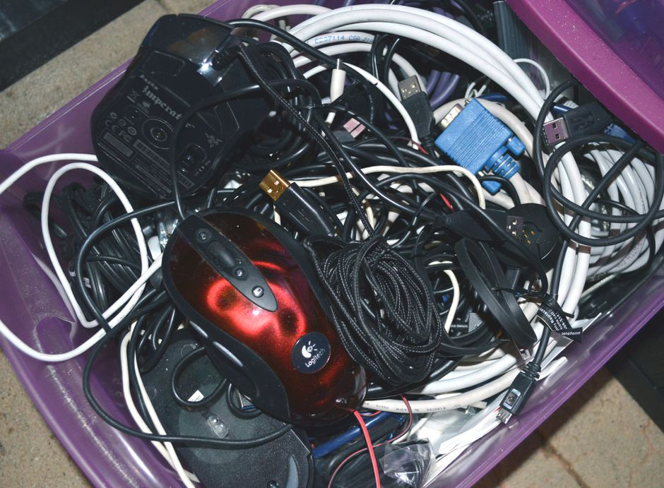
Have you got a box or a drawer that looks like this at home? If so, what type of electrical items are in there and why you keep them.

How many units of electronic items did DELL ship in 2019?
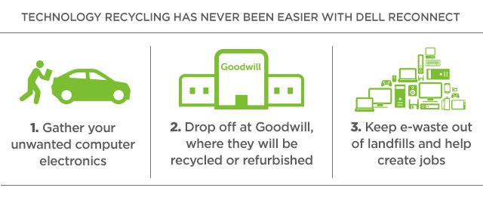

Watch the first video on ibgeographypods and study the image on the previous page. Outline the DELL Reconnect scheme.

Watch the first 5:15 ‘The Story of Electronics’ video on ibgeographypods. Take notes on the concept of ‘designed for the dump’ and ‘planned obsolescence.

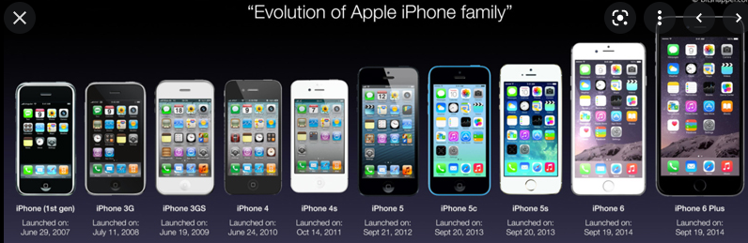

Study the image above carefully, including the release dates. These are old iPhones, but the sequence shows the year-on-year product upgrades. To what extent can a smart phone be considered to be products designed for ‘planned obsolescence’?

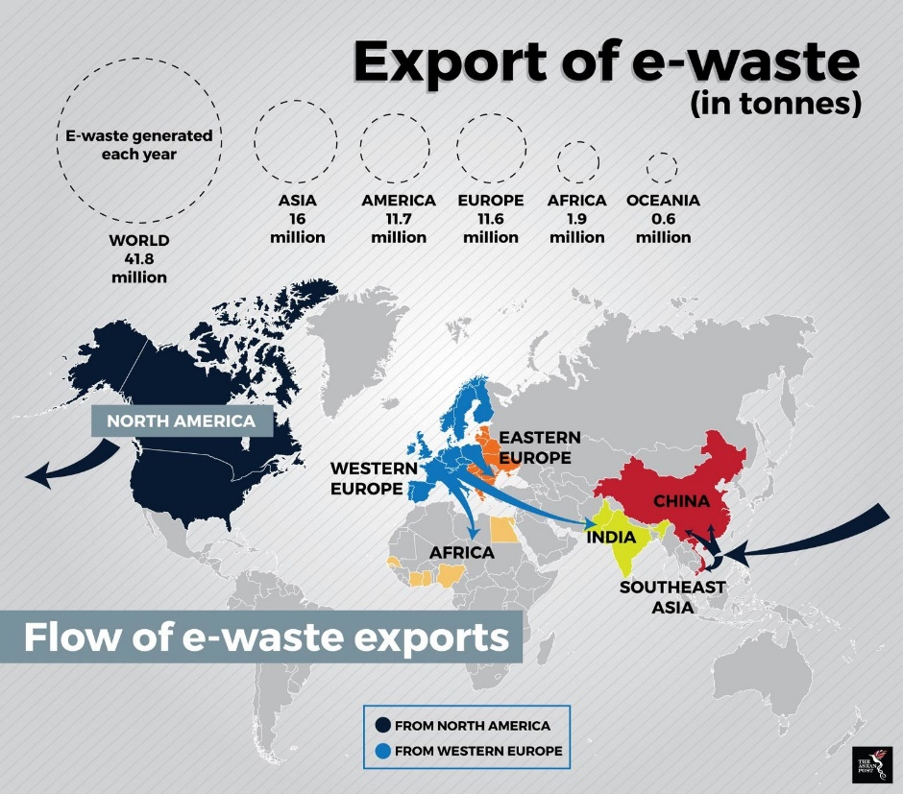
Describe and explain the global flows of e-waste from users to where it is often disposed of.

Make a list of the main reasons why HICs are exporting e-waste to MICs and LICs. Which key powers may be involved here?

Spend 10 minutes researching the Basel Action Network (Power). Outline their main aims and objectives including the main damaging processes that they are aiming to end.

Now, watch the second video on ibgeographypods by ‘The Circuit’.

What are the common misconceptions by the public regarding where their e-waste ends up?

Where did most of the tracked devices end up? Write some notes about ‘The New Territories’ and what role it plays in the decommissioning of e-waste. Outline any hazardous materials and key powers that are mentioned / implicated in this process.

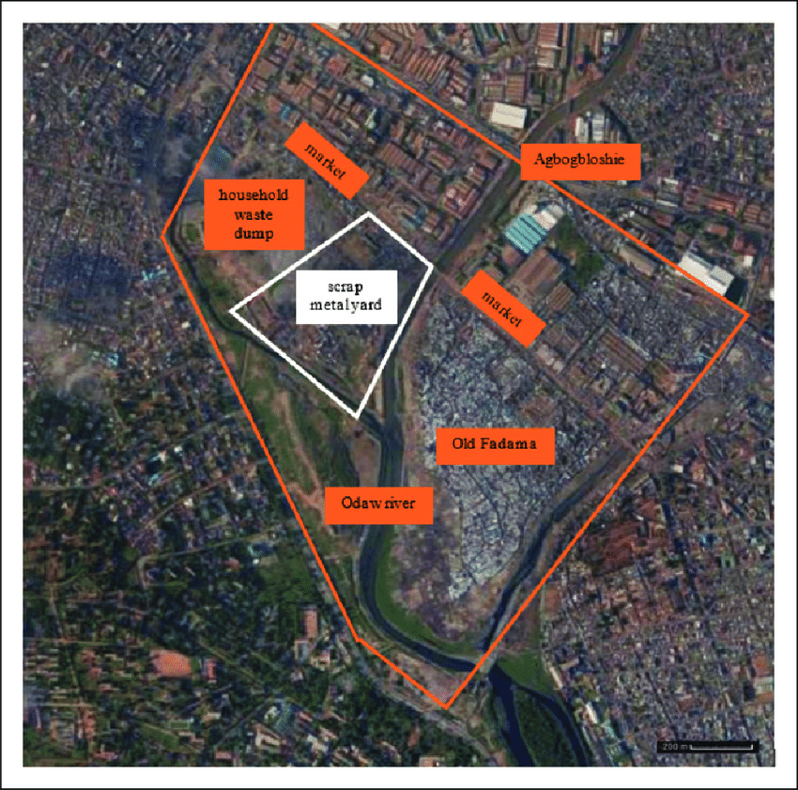
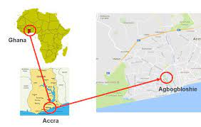

Using the two embedded Google Streetview images on ibgeographypods, describe three obvious impacts of the disposal of international waste on the environment in Agbogbloshie. Here is a link to the Google map to match the image above.
1
2
3

Using the drone video and BBC video on ibgeographypods, describe the socio-economic costs of e-waste disposal on communities in Agbogbloshie.

Paper 2 – Infographic Question Example

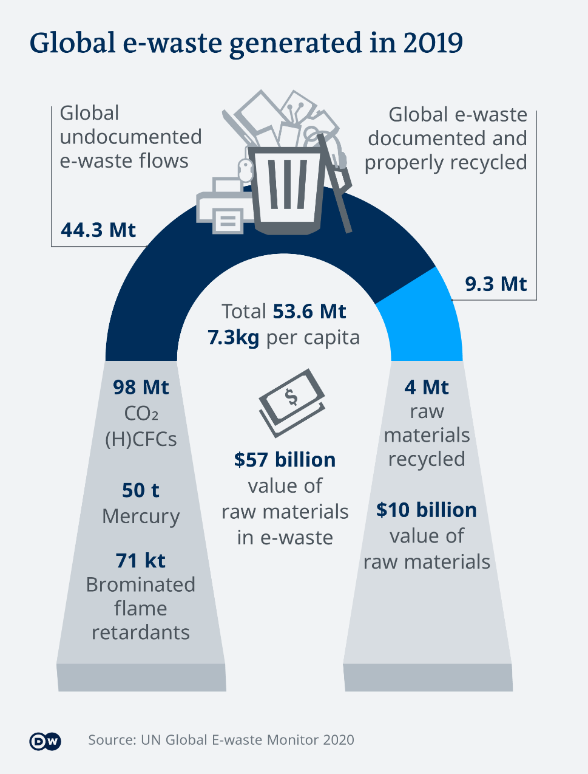
United Nations | Good points |  | Criticisms
General design
Layout
Readability
Data
Calculate the value per MT of raw materials in e-waste?
Calculate the % of total e-waste that is properly recycled.

