IB Geography – Distribution of Volcanic Activity
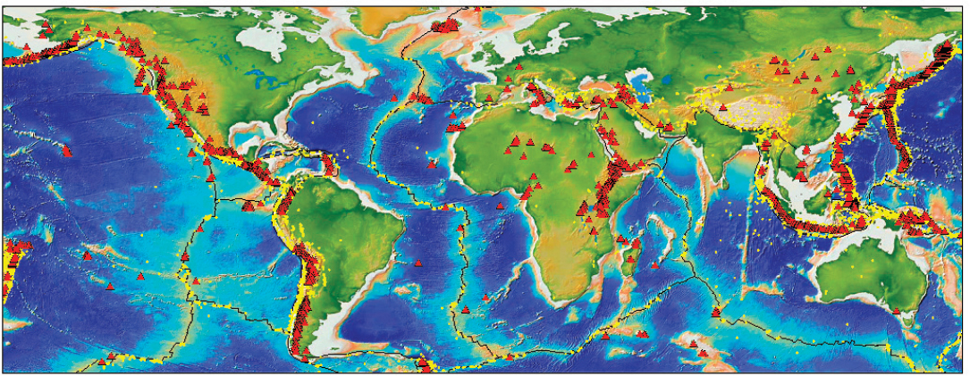
Starter – What are volcanoes? Using the embedded video on geographypods, make notes in the space below.

Task 1a. Using the map above, describe the spatial distribution of volcanoes around the planet making reference to and naming the areas of highest concentration.

Task 1b. Compare the map above with the plate boundary map in the 'Earthquakes' section. Which type of plate boundary is most associated with volcanic activity? Link to image here.

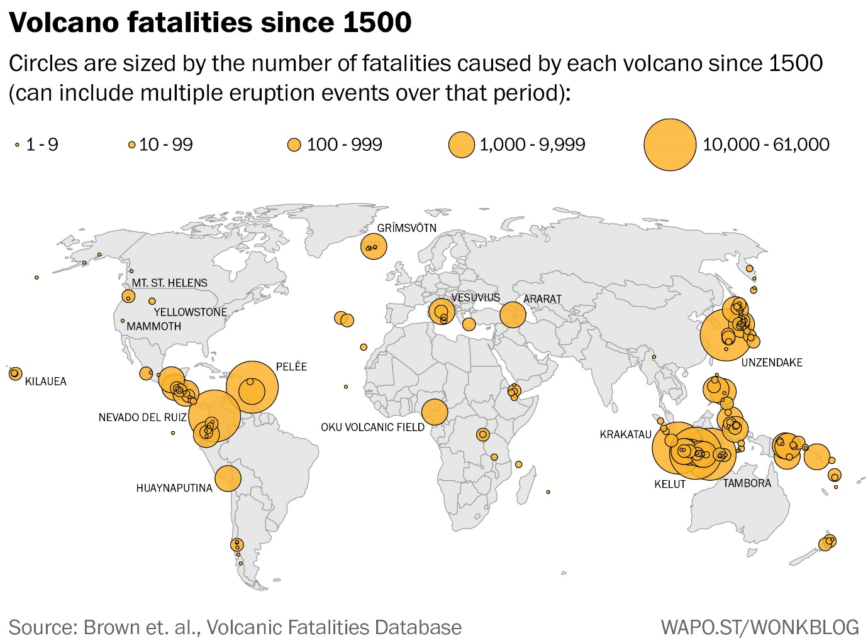

Task 1c. Using the image above, describe where the most dangerous volcanic areas are (in terms of human deaths) and offer at least one explanation for the high death rate in a certain region.

Task 1d. Now go back to the first video and watch from 19.45 to 21.38 to find out about why Hawaii is volcanic despite being thousands of KM from a plate boundary. Take notes.

Insert an image in the space below to compliment your notes in Task 1d.

Task 1e. Which major mountain ranges also have volcanic activity? What are the links between volcanic activity and the formation of 'fold mountains’? Use the map below as stimulus.

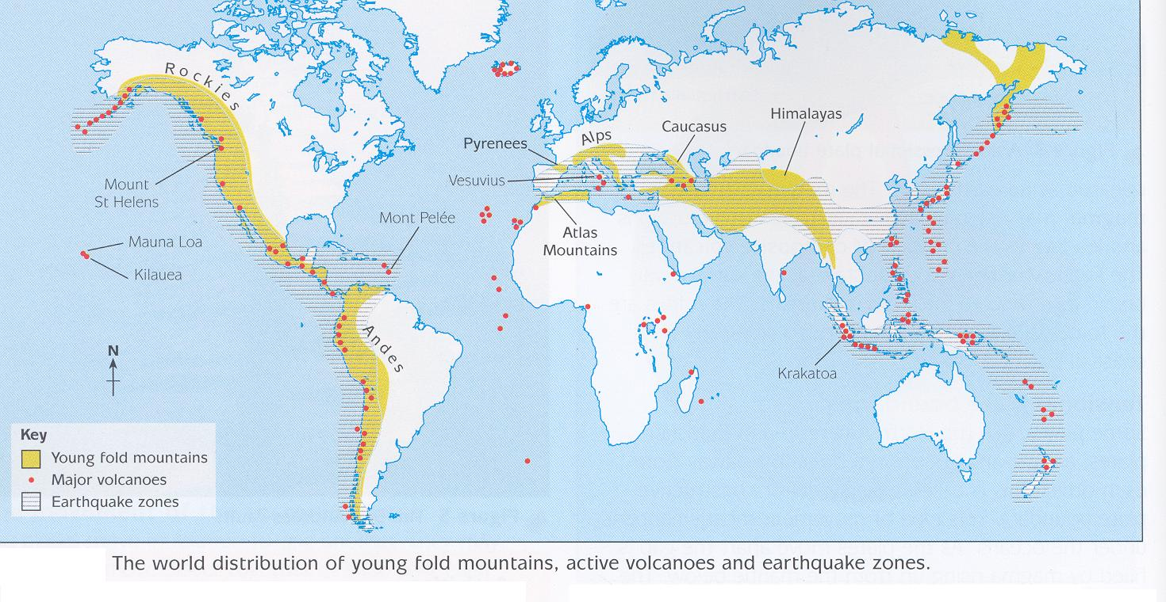
Source: jkgeography.com

