IB Geography – Distribution of Earthquakes
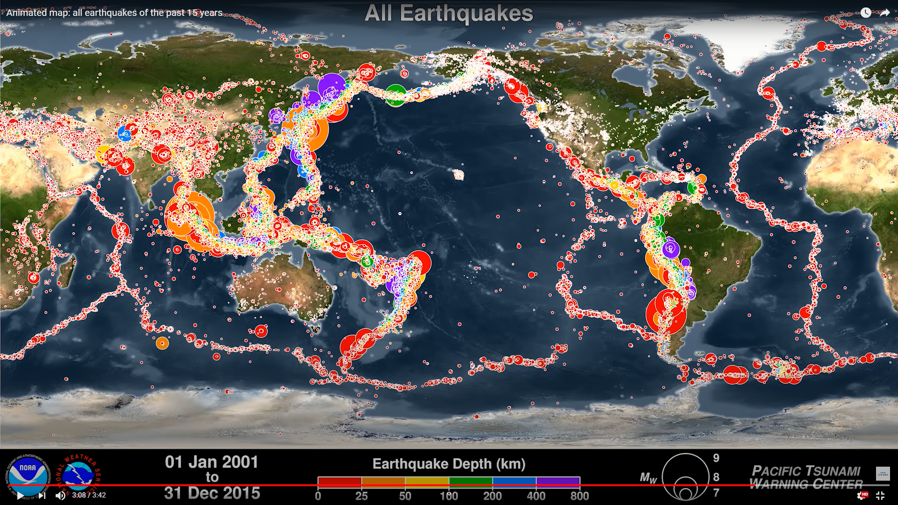
Task 1a – Using the map showing ‘all earthquakes’ (above), describe the global distribution of earthquakes and name one area where they are particularly prominent.

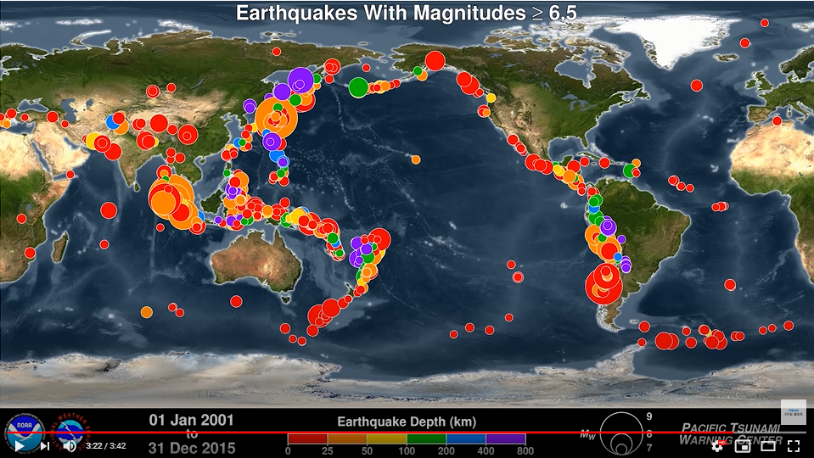
Task 1b – Describe the distribution of earthquakes of magnitude of 6.5 or above on the map.

Task 1c– Is there any relationship between magnitude and depth on this map?

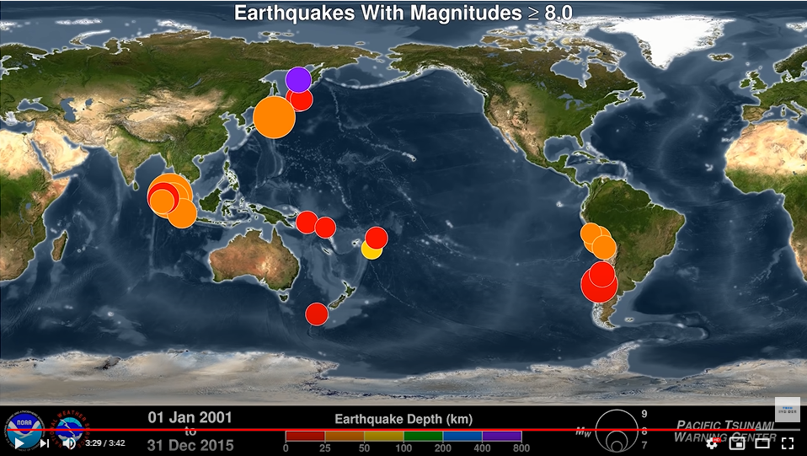

Task 1d – Describe the distribution of earthquakes of magnitude of 8.0 or above on the map.

Task 1e– Is there any relationship between magnitude and depth on this map?

Task 2 - Spend four minutes watching the second video to the right. What is a subduction zone and how do these zones cause earthquake activity?

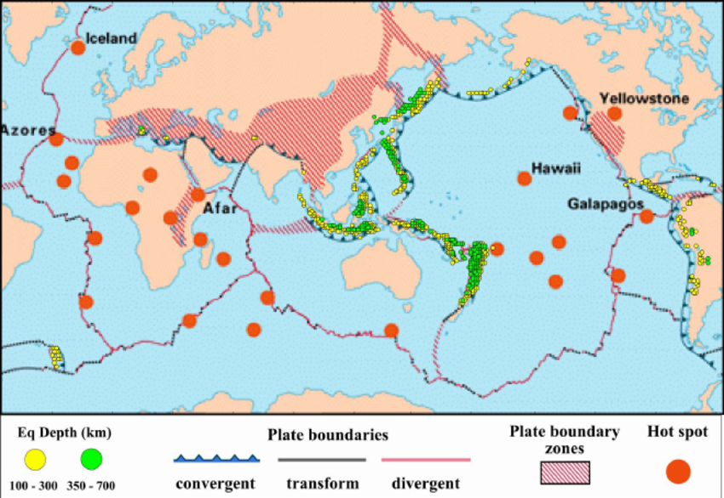

Task 3a. Which type of boundary is associated with subduction zone earthquakes?

Task 3b. Describe the spatial distribution of the potentially damaging shallow (100-300km) earthquakes globally.

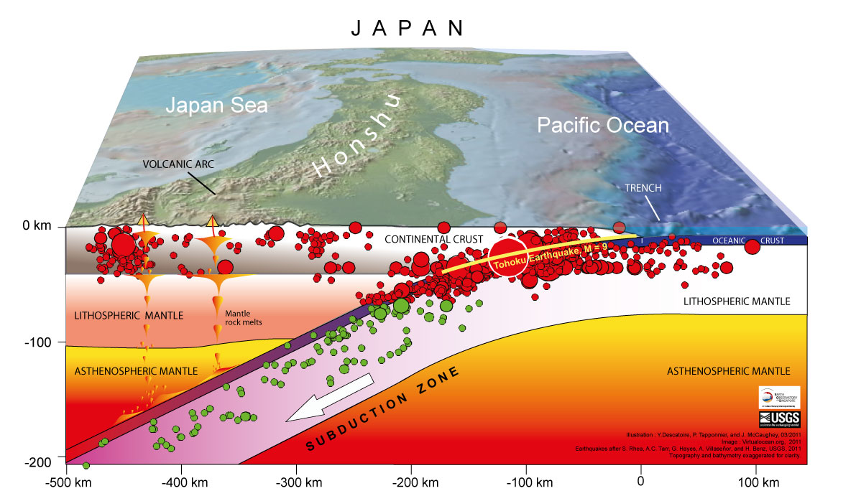
Source: Here
Task 3c. Using the image above, describe the frequency and potential severity of earthquakes in the Japanese subduction zone according to depth.

Task 3d. Using the image from task 3c, identify what additional tectonic hazard is produced as the Oceanic crust descends into the Asthenospheric Mantle?

Task 4 - Watch the embedded video on liquefaction and makes notes on how earthquake events can be linked to mass movement events.

