IB Geography – Dependency Ratios

Term | Definition
Young Dependent
Old Dependent
Economically Active

How is an overall dependency ratio calculated?
How:

What it means: The ratio for an HIC usually lies between 50 and 75. The ratio for an LIC is typically higher. The higher the ratio, the greater the number of dependents that must be provided for from the taxes on the workforce.

What factors can lead to a high dependency ratio within a country? Create a spider diagram.

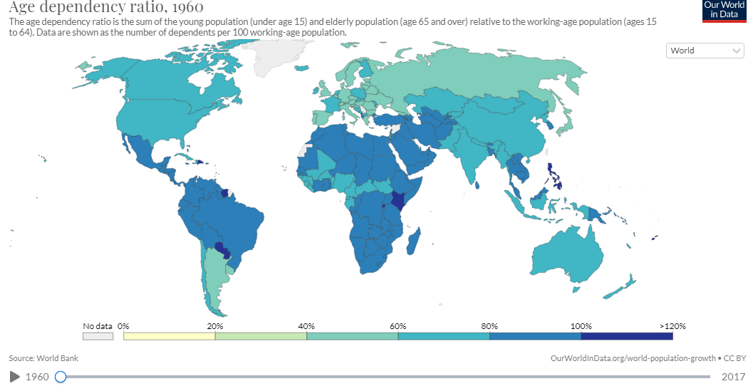

Describe the distribution of countries with a high age dependency ratio in 1960 and explain whether they are likely to be linked to a young or old dependent issue.

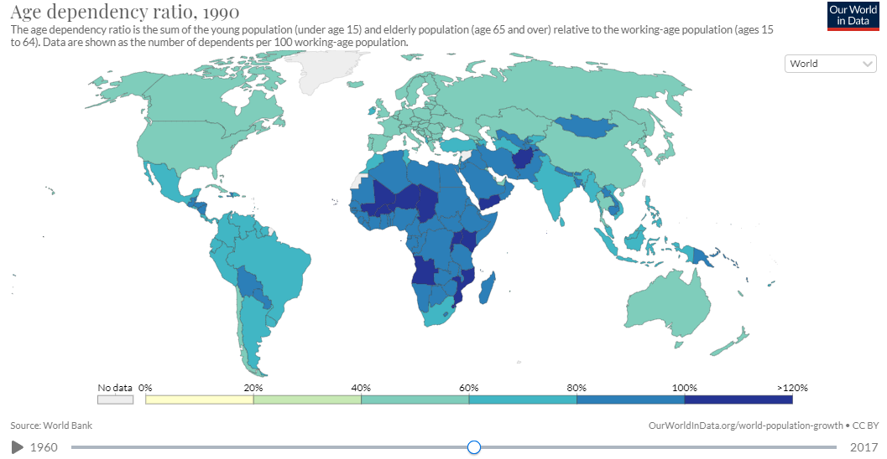

Describe the changes by the year 1990 and suggest reasons for these changes.

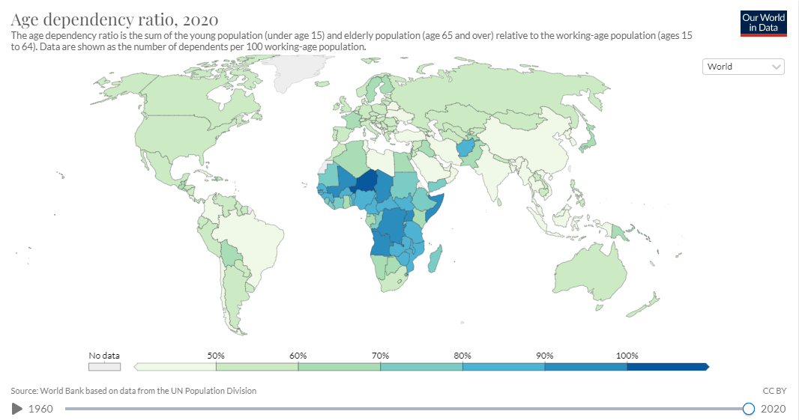

Describe the changes by the year 2020 and suggest reasons for these changes and evidence that old age dependency is more prevalent in certain countries.

Challenges for HICS | Challenges for MICS & LICS
1  2  3 | 1  2  3

