1.3 - Population Opportunities – The Demographic Dividend
What is a demographic dividend?

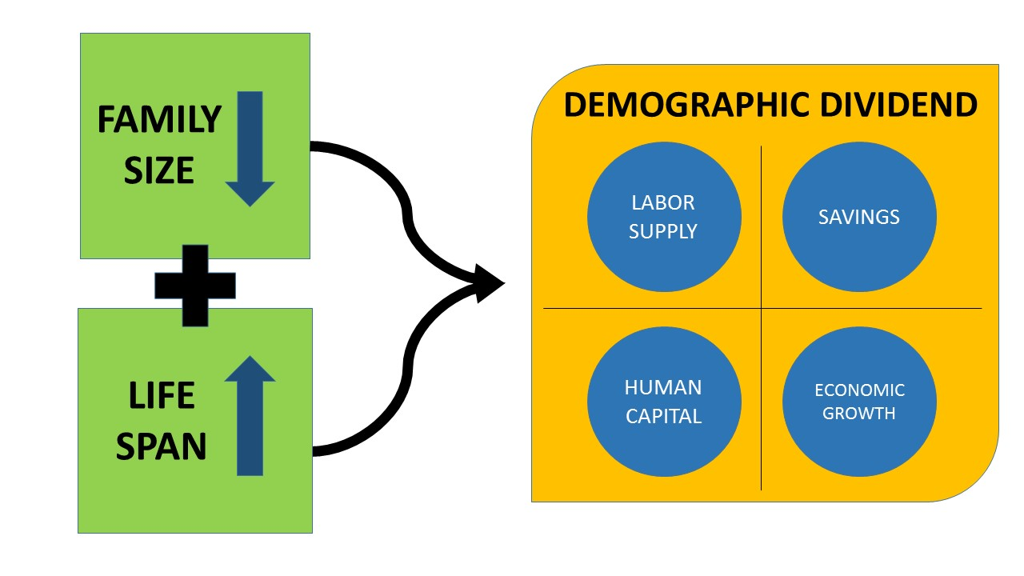

In your own words, explain how a reduction in family size and an increase in life span (expectancy) can lead to a demographic dividend. What factors can lead to these changes?

Using the article on geographypods, outline the benefits of the demographic dividend as set out on the model on the previous page.
- Labour Supply
- Human Capital
- Savings
- Economic Growth

Outline the barriers that can exist to countries being able to achieve a demographic dividend.
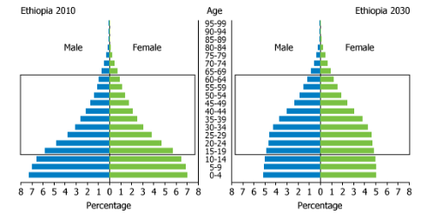

Based on the information in the population structures above, to what extent is Ethiopia likely to benefit from a demographic dividend in the future?

Using the article hyperlinked on geographypods, outline the driving factors behind the move to a demographic dividend in Ethiopia, as well as the work still to be done. Use data.
Factor | Progress so far | Work still to be done
Health
Education
Jobs

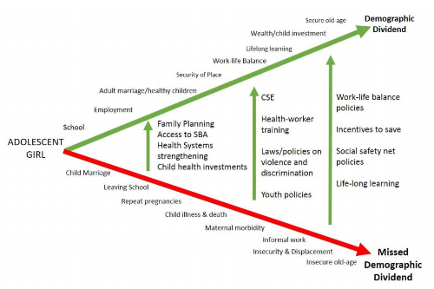
Using the graphic above, identify an early intervention that can stop an adolescent girl from heading into the cycle of poverty and not helping a country to enable a demographic dividend.

In conclusion
Whether or not Ethiopia will see the benefits of a demographic dividend remains to be seen but the outlook is hopeful.

Ethiopia is well positioned to benefit from a demographic dividend if fertility continues to decline and the current large young population is able to find productive employment.

Appropriate economic policies that promote growth will improve the gross domestic product and grow savings. However, the future gains will become much more impressive should these economic policies be matched with improvements in education, health, and family planning.

Such a focus on Ethiopia’s young population will guide the country towards the “economic gift” of a demographic dividend allowing for the benefits of labour supply, savings, human capital and economic growth to follow.

