IB DP Geography – Physical Risks to Supply Chain
Case Study Coronavirus – China
Key Definitions
Supply chain is defined as a “network between a company and its suppliers to produce and distribute a specific product to the final buyer. This network includes different activities, people, entities, information, and resources.”(Investopedia).
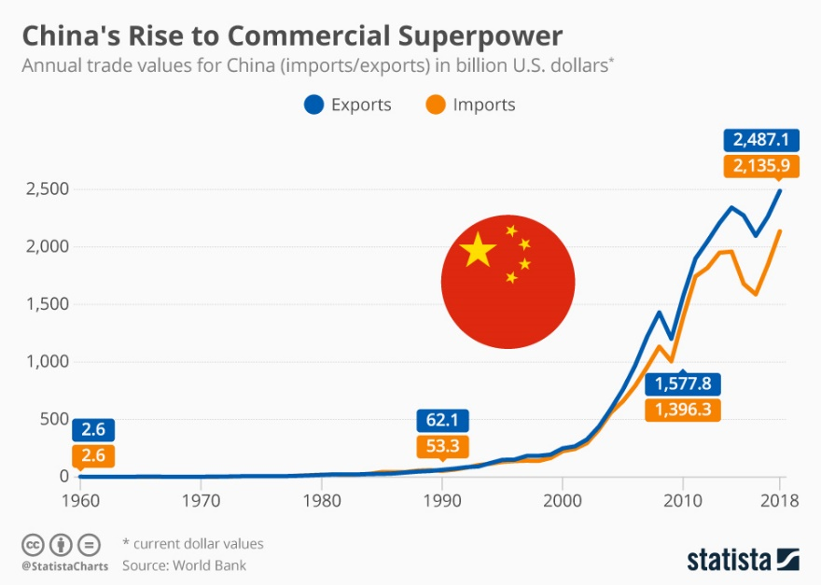

Use the chart above to explain the significance of the coronavirus on Chinese manufacturing and export.

Define the term ‘pandemic’.

Outline what the Coronavirus is and how it is spread.

Research the current infection rates and deaths. Add this information below (**note this is likely to change in the short to medium term**)

Outline the economic cost of this physical risk factor (Coronavirus) to the Chinese economy. Use data from the FT article.

Case Study 1 -

Case Study 2 -

Click here to read an article from The Guardian from 6th Feb 2020. Outline how the trade war between the USA and China could be deescalated by the Coronavirus.

