IB DP Geography – Rainwater Harvesting using Sand Dams in Kenya
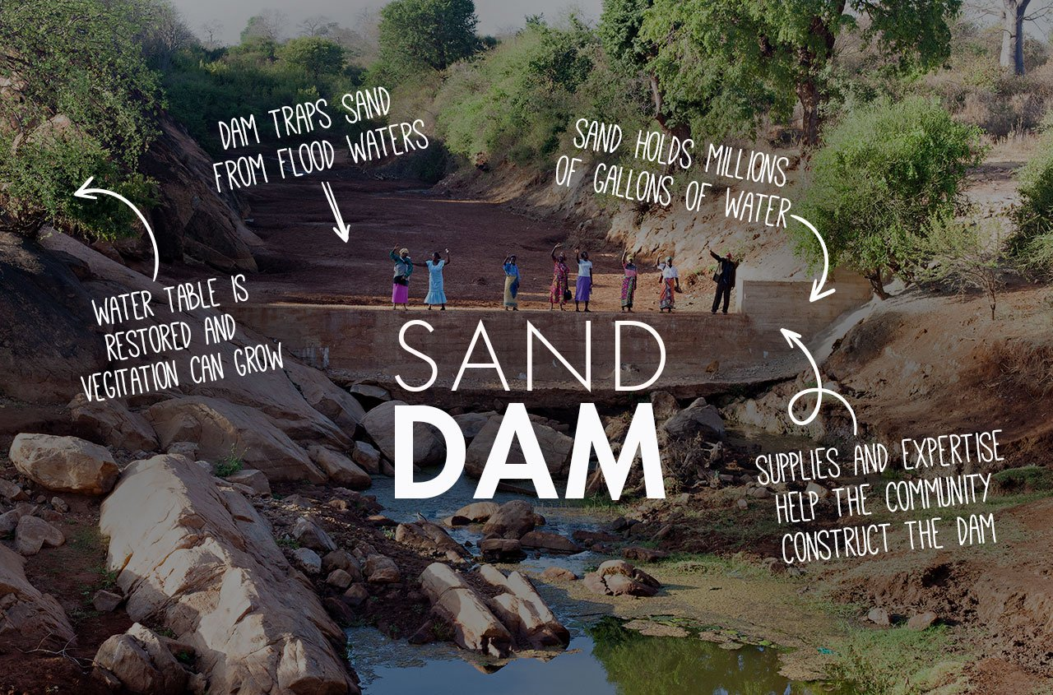
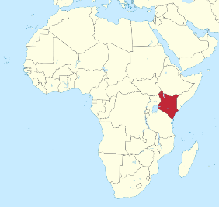

Issues in Eastern Kenya with water supply | How the Sand Dam is funded and constructed
How sand dams impact on the local communities | Synthesis Opportunities
Gender Equality

Nexus

SDGs

IB DP Geography – Glacial Runoff Harvesting - The Ice Stupa Project
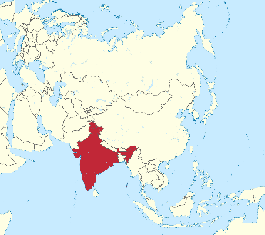
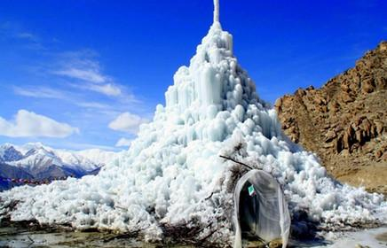
Issues in Ladakh with water supply | How the ice Stupa is funded and then created
How Ice Stupas impact on the local communities | Synthesis Opportunities
Climate Change

Nexus

SDGs

