IB DP Geography – Climate & Methane Gas Release & Feedback

Process | Place
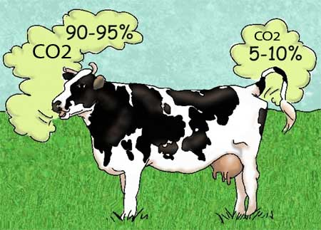

Power | Possibility

Perspectives….

