IB DP Geography – Characteristics of Earthquakes
An earthquake is a series of vibrations that emanate from a focal point below the surface of the Earth as tectonic plates experience a sudden release of pressure. Earthquake events are increasingly turning into large scale disasters when you consider ever expanding urban areas locate on or close to plate boundaries. This can be best illustrated using this excellent map produced by Dr Ben Hennig at the University of Sheffield. You can see a larger version on ibgeographypods.
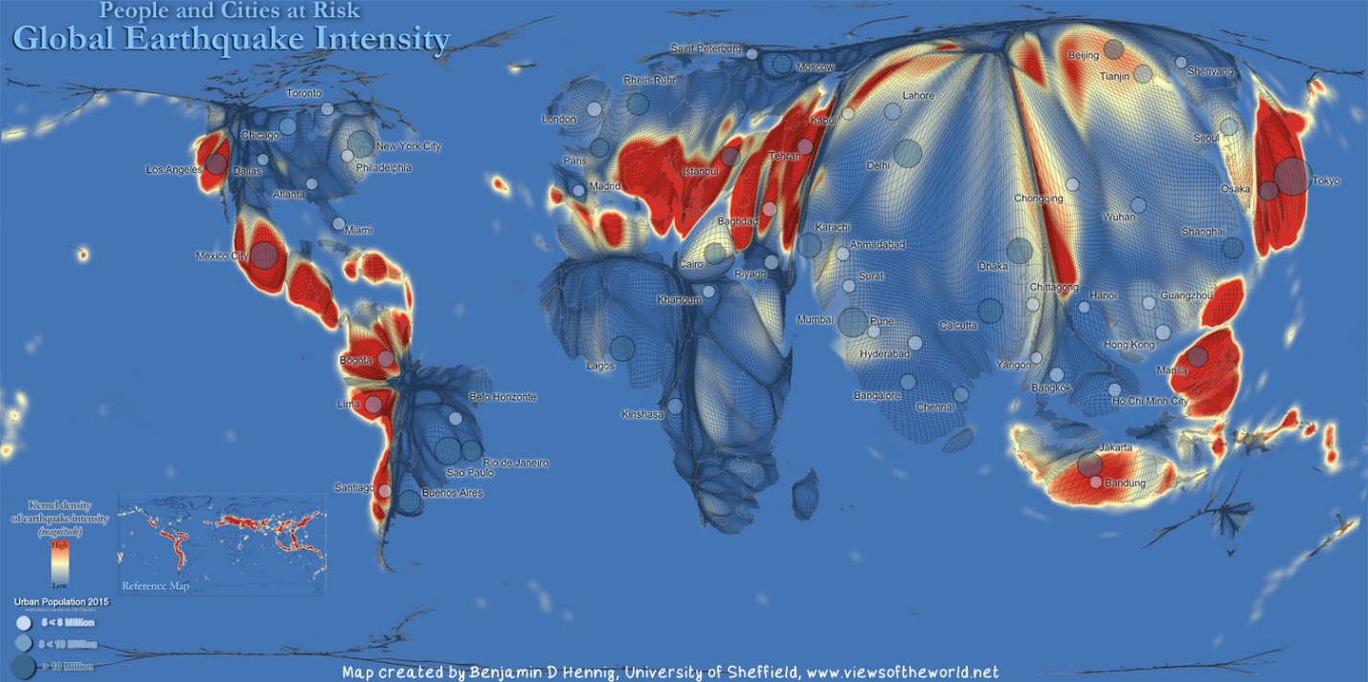
Focus & Epicentre
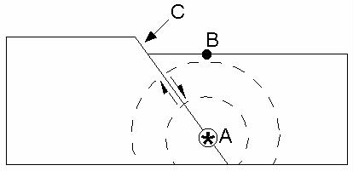
It is important to understand the difference between two key Geography terms when discussing the science behind earthquakes. The diagram below shows a cross section through two plates at the point where they meet.

Task 1 - Label the following features onto the diagram above (A,B & C) .
- Focus. The point within the plate where the rocks start to fracture. It is the origin of the earthquake.
- Directly above the focus on the Earth's surface is the earthquake epicenter.
- Fault lines represent fracture lines on the surface of the Earth where tectonic movement occurs.

Task 2 – Using the link on ibgeographypods, complete some note taking on the differing depths of the focus of earthquakes using the categories below.
Category | Depth KM | Characteristics | % of total earthquake energy released.
Shallow
Intermediate
Deep

We are now going to turn our attention to how the shock waves are transferred through the surface of Earth directly after an earthquake. The basic diagram below is your starting point.

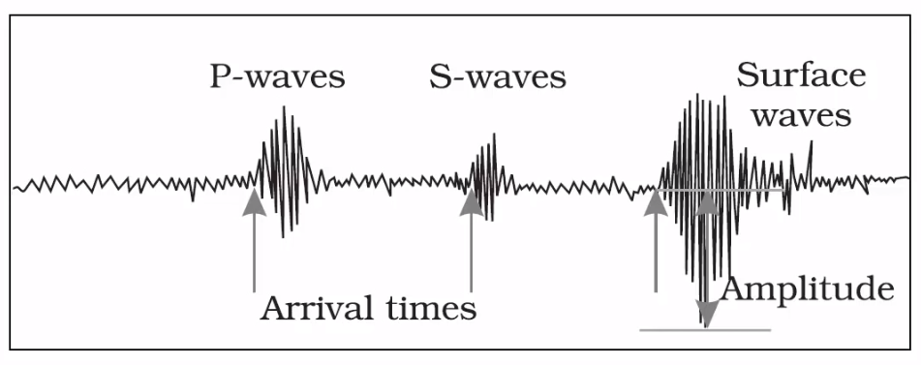

Task 3 – Now watch the video embedded on ibgeographypods and complete the following information gathering exercise. For the detail of Love & Raleigh waves, you will need to use the second weblink available on ibgeographypods.
Body Waves  Describe them here  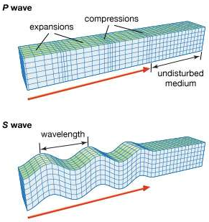 | P Waves | Describe
 | S Waves | Describe
Surface Waves  Describe them here  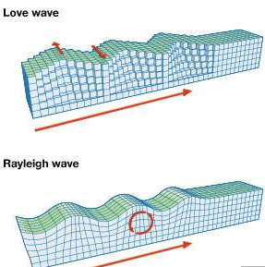 | Love Wave | Describe
 | Raleigh Wave | Describe
Images: Encyclopædia Britannica, Inc.
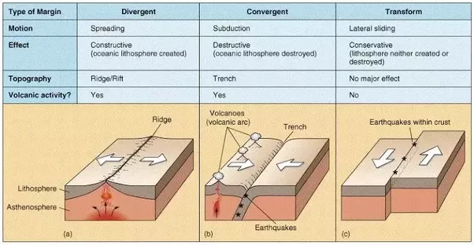

Earthquakes & Plate Boundaries
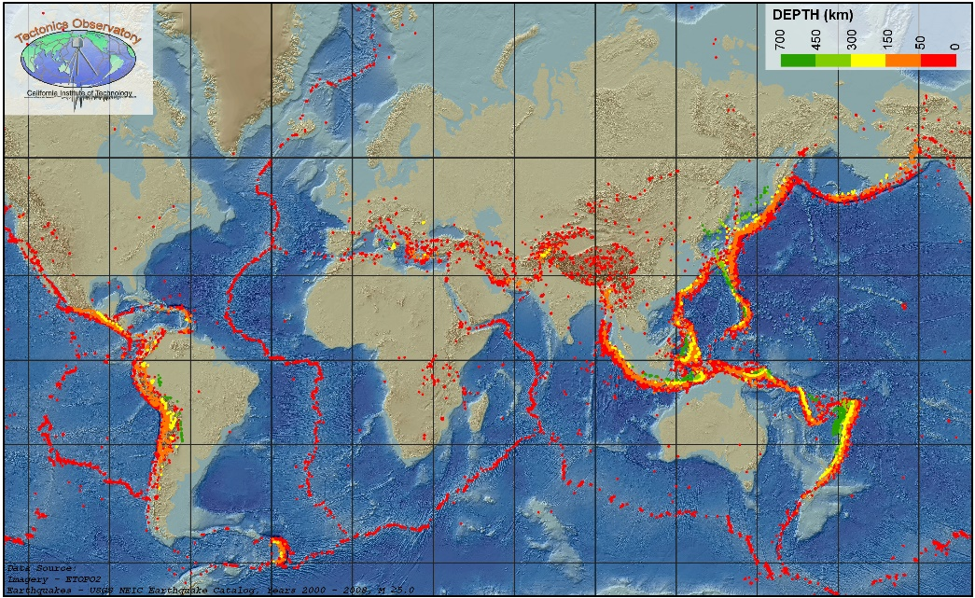
Task 4 – Using both maps above and below as well as the table on the previous page, create a summary of the relationship between intensity of earthquake activity (depth map) with the type of plate boundary associated with that movement.
