IB DP Geography - Classification of Mass Movement
Type | Photo of event | Clear diagram to show process | Find out about….
Landslide (dry) / Rockfall |  | 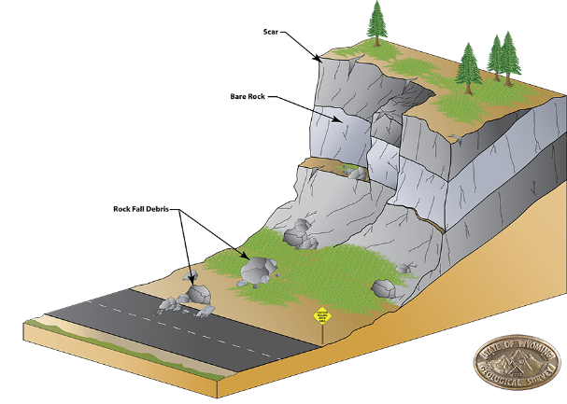 | Liquidity  Speed of onset  Duration  Extent  Frequency
Mudflow (wet) |  | 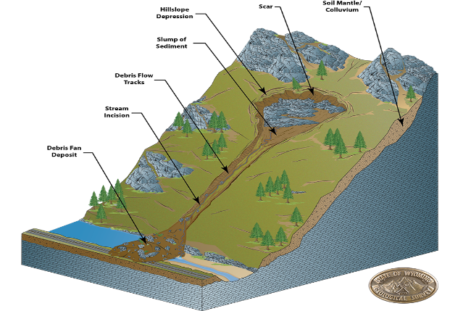 | Liquidity  Speed of onset  Duration  Extent  Frequency
Soil Creep |  | 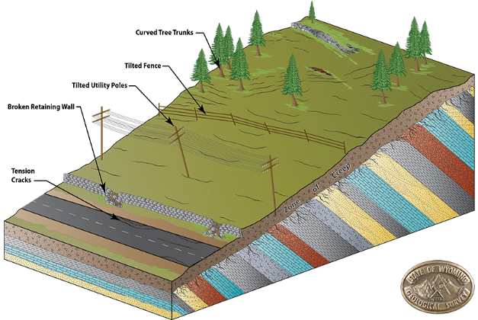 | Liquidity  Speed of onset  Duration  Extent  Frequency
Slumping |  | 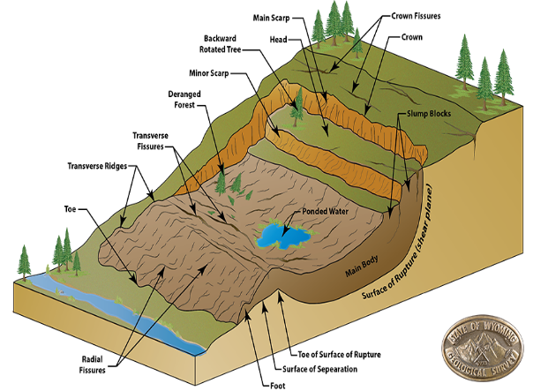 | Liquidity  Speed of onset  Duration  Extent  Frequency
Conduct some research in the space beneath into one mass movement event caused by human action.

Source of images – here.

