IB Geography – The Inquiry – How Soon Can We Go Carbon Zero?
Episode Broadcast 07th November 2019
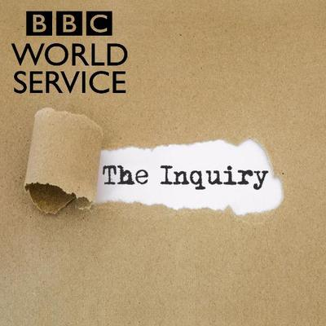

Background ‘need to know’
Who are ‘Extinction Rebellion’ and what do they demand?

What happens when CO2 is released into the atmosphere?

You will now hear from four key witnesses, each of who has a different perspective on the whether or not the world can reach carbon zero by the year 2050 (or even at all!).

Part 1 – Keeping The Lights On (Process & Possibility)

Take notes on what witness 1 - Roger Pielke Junior, Professor at the University of Colorado – has to say.
Since 1990 …..

‘Net Zero’ is …..

Biggest source of CO2 is …..

____% energy from fossil fuels today.

How hard can it be to wean ourselves off fossil fuels (make a note of what he has to say about replacing fossil fuels between now and 2050).

BUT, 2 billion plus people …….

How many nuclear power stations in the whole world today? ______

How many would need to be built by 2050 to replace fossil fuels? ______

What about using the technology of wind and solar? Make notes here:

HOW SOON DOES ROGER PIELKE THINK WE COULD REACH CARBON ZERO

Part 2 – Getting Around (Possibility & Power)

Take notes on what Rachel Moncrief, deputy director at the International Council on Clean Transportation, has to say.
What were VW caught doing recently?

Transport contributes ……

What is the transport breakdown of CO2 emissions:

Rail %, Heavy Goods Vehicles %, Shipping %, Aviation %

Outline further information about the electric vehicle market:

How can governments encourage uptake of electric cars?

Electric cars only cut carbon if they …

What types of transport are difficult to electrify?

HOW SOON DOES RACHAEL THINK WE COULD REACH CARBON ZERO?

Part 3 – Out of Africa (Power & Perspective)

Take notes on what Chukwumerije Okereke has to say. He is the professor in Environment and Development at Department of Geography and Environmental Science, University of Reading and director of the Centre for Climate Change and Development
Why is there a lack of urgency amongst African leaders to tackle climate change? What are the other issues that they face?

The entire continent of Africa contributes ________% of global greenhouse gas emissions.

Africa will experience a population doubling by 2050, what issues does this cause for African governments?

“The World Bank and the IMF are very good at planting trees in Africa, but that’s not what Africa needs. Africa needs ……

“

HOW SOON DOES THE PROFESSOR THINK AFRICA COULD REACH CARBON ZERO?

Part 4 – Making the Carbon Disappear (Possibility).

Take notes on what Mercedes Maroto-Valer has to say. She is the Director of the Research Centre for Carbon Solutions at Herriot Watt University in Edinburgh, Scotland
How does Carbon Capture & Storage (CCS) work?

How much can the technology capture _________%

There are only 40 such units operating around the world. Why is it not widely used?

Norway captures and stores 1 million tonnes per year. This sounds like a lot but ……

HOW SOON DOES MERCEDES THINK AFRICA COULD REACH CARBON ZERO?

Summary Conclusion 21:40 onward.

