IB Geography – Hazards & Disasters
Case Study Summary Sheet for Anak Krakatau Eruption 2018 (MIC)
Where did it happen?
The Anak Krakatau volcano is an island and caldera in the Sunda Strait situated between the islands of Java and Sumatra in the Indonesian province of Lampung. It lies on the Pacific Rim of Fire at the convergence of the Pacific, Eurasian and Philippine plates. The volcano has grown from the crater of the original site of the globally famous Krakatoa volcano that literally blew its self apart in 1883, sending large tsunami waves around the world (hence the name ‘Child of Krakatoa’). Anak Krakatau has been an active volcano ever since its emergence from the sea in 1927 and its growth has accelerated since the 1950’s with the island growing on average of approximately 7 metres per year.
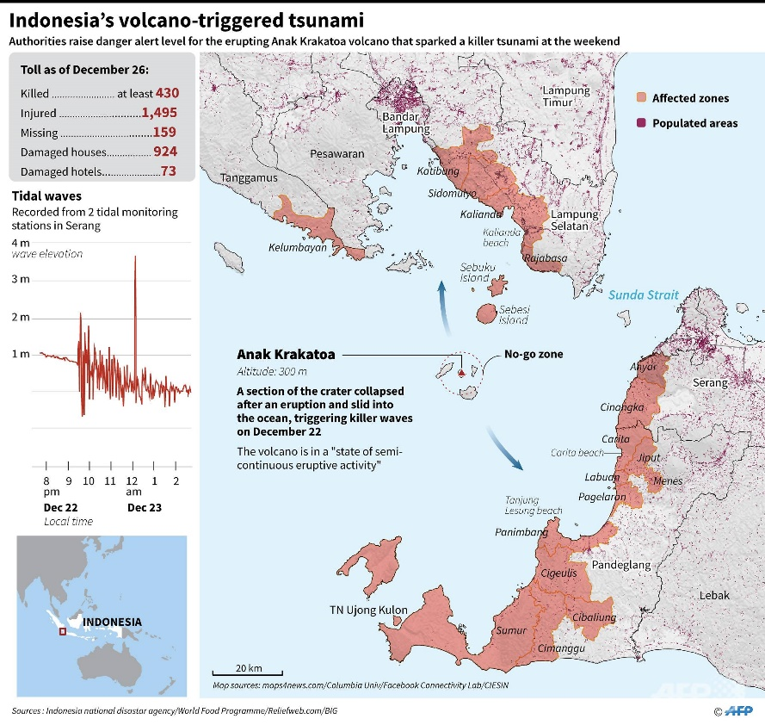
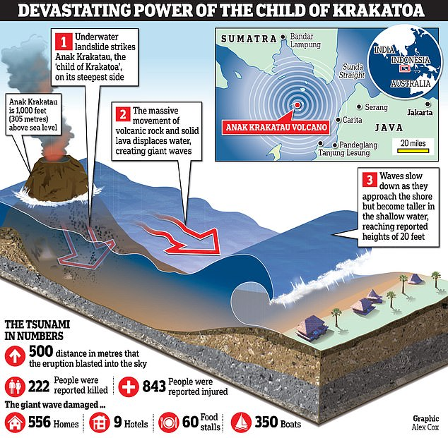

Geo Fact Box – Indonesia Need To Know
Indicator | Values (2017 estimated)
GDP per capita PPP | $3850
People Living in Poverty (less than $2 per day) | 10% of the population
Access to Clean Water | 90% of the population
Life Expectancy | 70 years
Literacy Rate | 95%
People Per Doctor | 0.02 doctors per 1000 people

When did it happen?
Date. 22 December 2018
Time (local). Tsunami struck at 21:30 local time
Duration. Large eruption leading to partial collapse of the volcano and subsequent tsunami affecting the adjacent coastlines (see second map on page 1). This makes the eruption the deadliest volcanic eruption of the 21st century.
Why did it happen?
After the December 22 eruption, the southwest sector of the volcano, including the summit, collapsed, triggering a tsunami. On 23 December this was confirmed by satellite data and helicopter footage, with the main conduit erupting from underwater. The volcano lost over two-thirds of its volume due to this event, and elevation above sea level was reduced to 110 m from 338 metres. Check out the interactive slider graphic on this BBC page for a clearer picture.
Who was affected by it happening?
Social Impacts | Economic Impacts
437 confirmed dead (as of Feb 2019)  14,059 injured. Thousands living in displacement camps (Feb 2019).  The fact that the tsunami was triggered by a volcano rather than an earthquake meant no tsunami warning was triggered  More than 600 homes, 60 shops and 420 vessels damaged when the tsunami struck  International Federation of Red Cross and Red Crescent Societies sent aid workers to help evacuate injured people, bring in clean water and tarpaulins, and provide shelter. | Damage to coastal fishing communities  Damage to coastal domestic tourism facilities  Damage to infrastructure such as roads, bridges and coastal defences.  **Feb 2019 Update** - Further cracks have been detected on the flanks of the volcano leading to fears that a second tsunami event might occur.
Environmental Impacts | Political Impacts
Coastal farming areas inundated with salt water rendering the areas useless for agriculture.  Sea turtle populations harmed and rescue of turtles carried out by rescuers.  All biodiversity on Anak Krakatau wiped out by the eruption. | Indonesia’s tsunami warning buoy network had not been operational since 2012. According to a government minister, vandalism, a limited budget and technical damage mean there were no tsunami buoys at the time of the eruption and subsequent tsunami.

Impacts of these hazards on different aspects of human well-being
Health | Shelter
Food | Water

Why levels of vulnerability varied both between and within communities
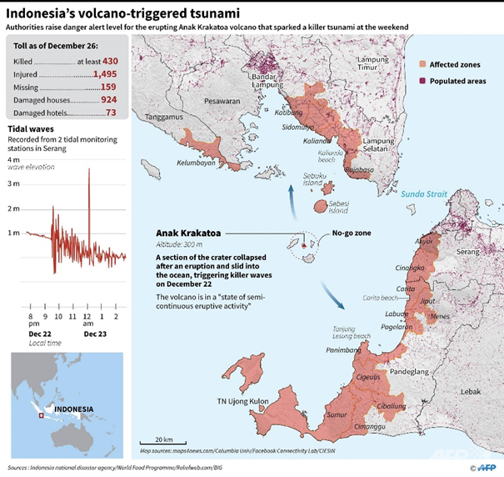

Comment on the spatial distribution of population density around the coastlines adjacent to the volcano.

Comment on the relationship between the locations of the affected zones, the time of the event, the distance to the shore and the subsequent death toll.
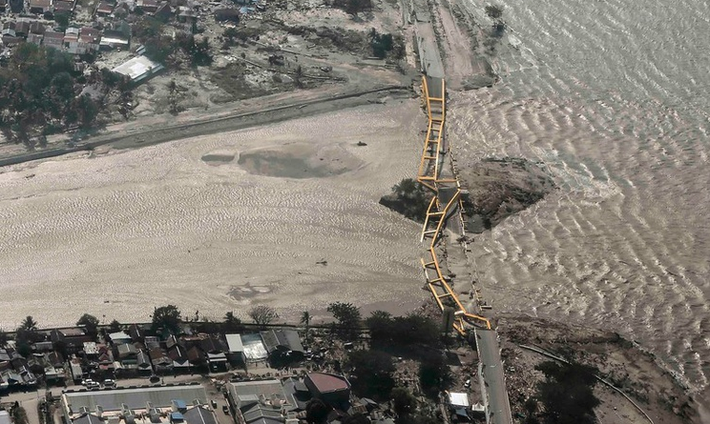

Study the image above carefully. Explain how population density along the coastline, building design and distribution, as well as the faulty tsunami warning system could have increased levels of vulnerability in Palu (Indonesia).

