IB Geography – Hazards & Disasters
Case Study Summary Sheet for Alaskan Earthquake (USA - HIC)
Where did it happen?
Alaska is the largest of all the United States and located on the northern most arc of the Pacific Ring of Fire. Historically, the country has experienced some of the most powerful earthquakes, but the regions low population density often means that the death rates are very low. The ‘megathrust’ nature of the plate in this region also heightens the risk of a tsunami and indeed, this was the case in this particular hazard event. The earthquake here hit at 8.29am local time with a magnitude of 7.0 on the Richter Scale. The epicentre was approximately 16km from the major settlement of Anchorage and was at a depth of 47km (shallow). Over the four days following the main quake, the region experienced 150 aftershocks, some of which registered 5 on the Richter Scale.
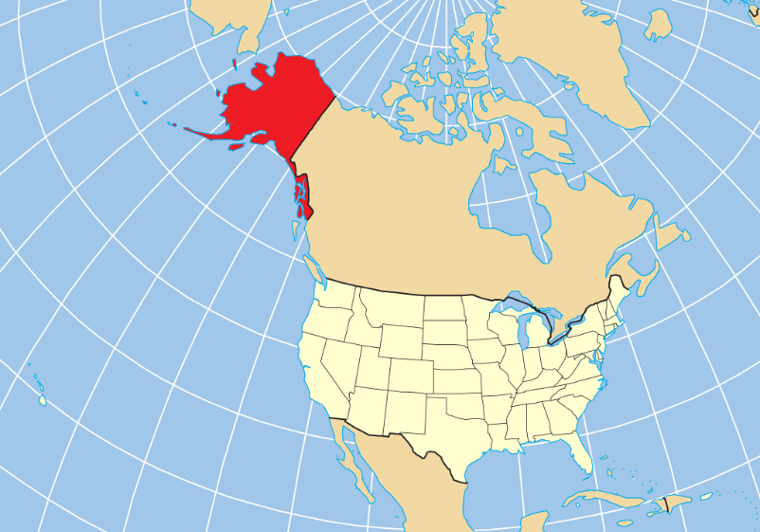
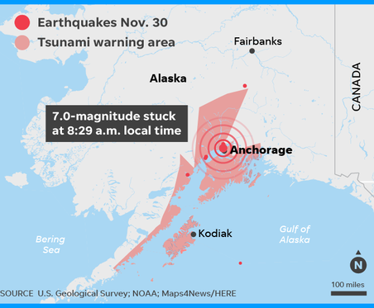
CIA Fact Box – USA Need To Know
Indicator | Values (2018 estimated)
GDP per capita PPP | $59500
People Living in Poverty (less than $2 per day) | 0% of the population
Access to Clean Water | 100% of the population
Life Expectancy | 76 years
Literacy Rate | 87%
People Per Doctor | 2.56 doctors per 1000 people
When did it happen?
Date. November 30th 2018
Time (local). 8:29am
Duration. A matter of seconds but in the proceeding 4 days, a total of 150 aftershocks were recorded.
The earthquake happened in early morning meaning that populations were up and around and on route to work. No foreshocks had been recorded and no advanced warning had been given of the forthcoming earthquake event. A tsunami warning was generated but was withdrawn shortly afterwards.
Why did it happen?
Southern Alaska lies at the eastern end of the Aleutian Trench, where the Pacific Plate is subducting beneath the North American Plate. Near Anchorage, the plates are converging at a rate of 57 mm per year. The region has experienced severe earthquakes in the past, including several megathrust earthquakes. The 1964 earthquake, with a magnitude of 9.2, was the largest earthquake in American history and the second largest to ever be recorded anywhere in the world. Though earthquakes are common in Alaska, they often occur out at sea.
Who was affected by it happening?
Social Impacts | Economic Impacts
Severe damage to buildings including houses and apartments.  No fatalities reported  Traffic lights knocked down causing serious traffic issues.  Several schools were damaged and subsequently shut. One student broke his wrist as he fled from the building during the earthquake.  Matanuska Electric Association reported that 46,000 customers were left without electricity immediately after the earthquake | The operators of the Trans Alaskan oil pipeline temporarily shut down the flow of oil until such time that a damage report was completed. No major damage to the pipeline was reported and normal flow resumed.  Damage in Anchorage was estimated to be at least US$30 million, including $10 million to repair pipes, and $10 million in public facilities.  Damage estimates to the Anchorage School District ranged from $25 to $50 million.
Environmental Impacts | Political Impacts
Liquefaction occurred in some areas.  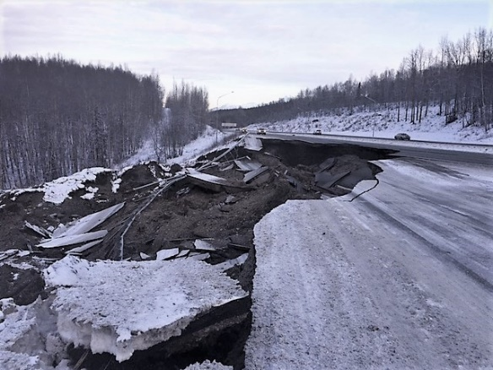  By Alaska Department of Transportation and Public Facilites - https://www.flickr.com/photos/akdotpf/46084915742/in/album-72157698296408660/, CC BY 2.0, https://commons.wikimedia.org/w/index.php?curid=74853577  No oil leaks from the pipeline this time. | President Donald Trump stated on Twitter, "To the Great people of Alaska. You have been hit hard by a 'big one.' Please follow the directions of the highly trained professionals who are there to help you. Your Federal Government will spare no expense. God Bless you ALL!"  A federal disaster was declared shortly after the earthquake and the Federal Emergency Management Agency deployed personnel from the state emergency operations center at Joint Base Elmendorf-Richardson to conduct relief operations.  Anchorage Mayor Ethan Berkowitz likewise declared a state of emergency for his city, and requested both state and federal assistance

Impacts of these hazards on different aspects of human well-being
Health | Shelter
Food | Water

Why levels of vulnerability varied both between and within communities
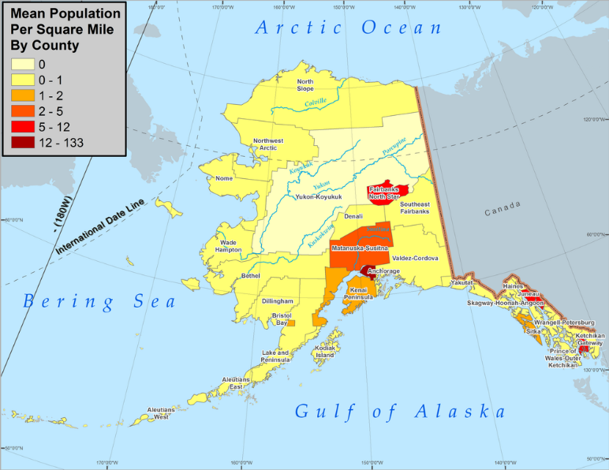

Comment on the distribution of population density in Alaska.
The population of Alaska is concentrated along the central southern coast, particularly around the settlements of Anchorage and Valdez. Anchorage has a population of close to 300,000 people today. The functions of these settlements are linked to the fishing and oil industries, with the Port of Valdez being the end of the Trans-Alaska pipeline. Oil wealth has created jobs in the area and this had led to further settlement growth. Much of central and northern Alaska is extremely sparsely populated due to its remoteness and severe climate.

Map to show the epicentre and intensity of shaking during the 2010 Earthquake Event.
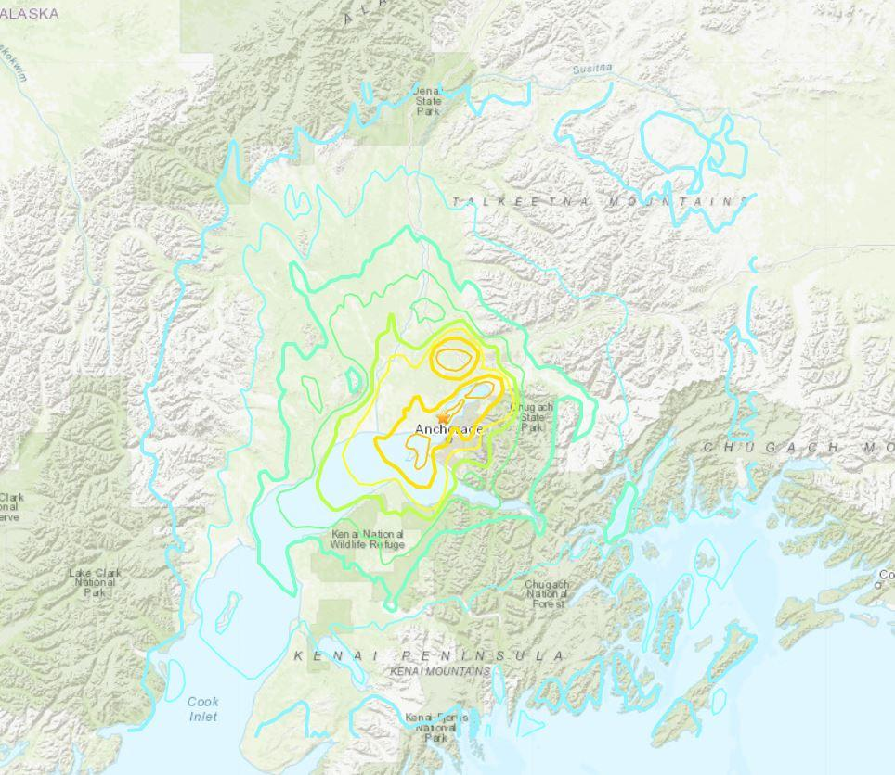

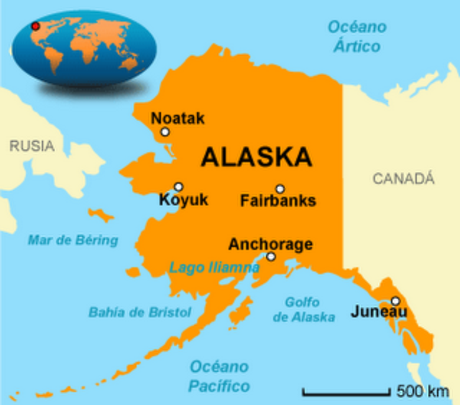

Comment on the relationship between the epicentre of the earthquake and population density of the country. What are the additional risks to coastal communities in this area of strong ‘megathrust’ earthquakes?
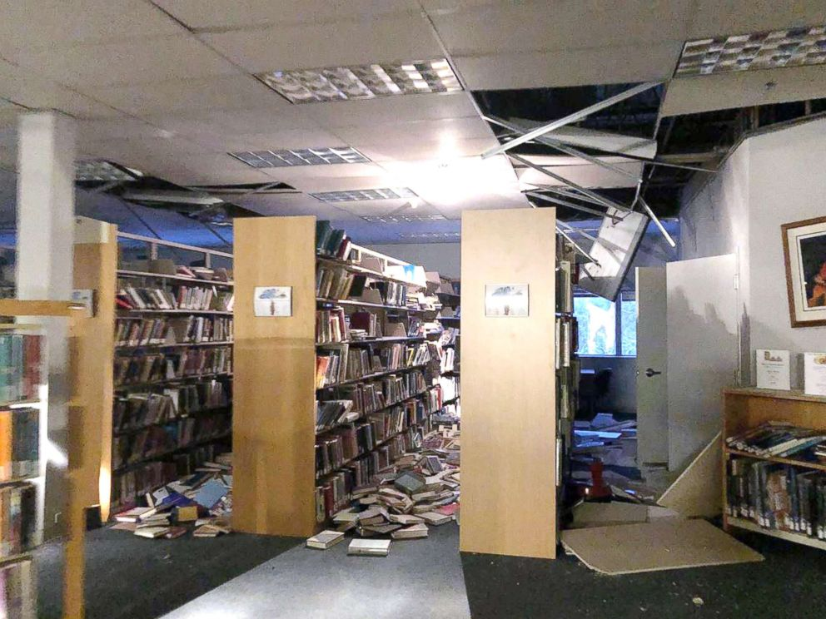
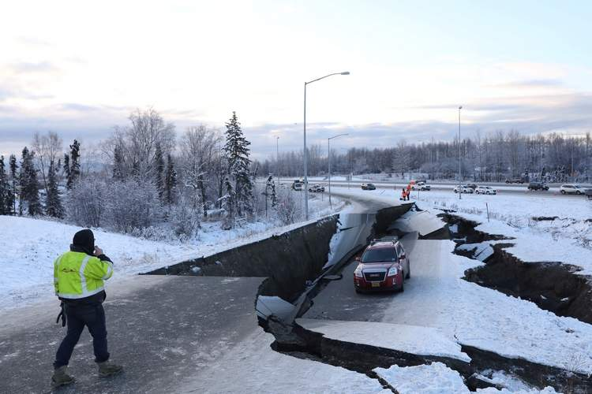

Study the images above carefully. Explain how the rural location of earthquake events in Alaska, the time of day and degree of isolation could play a part in future hazard events in the region.

As you now understand, similar magnitude earthquake events have very different outcomes depending on where in the world they strike. Read this article on preparedness in Anchorage and make some notes on the advice for what should be done before, during and after an earthquake.

Before | During
After | Evaluation of effectiveness of the scheme.

