IBDP Geography – Freshwater - Attempts at Flood Prediction

Flood Modelling | Improved weather forecasting | Limitations of climate models
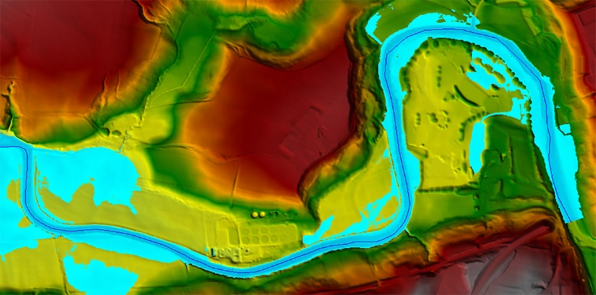 | 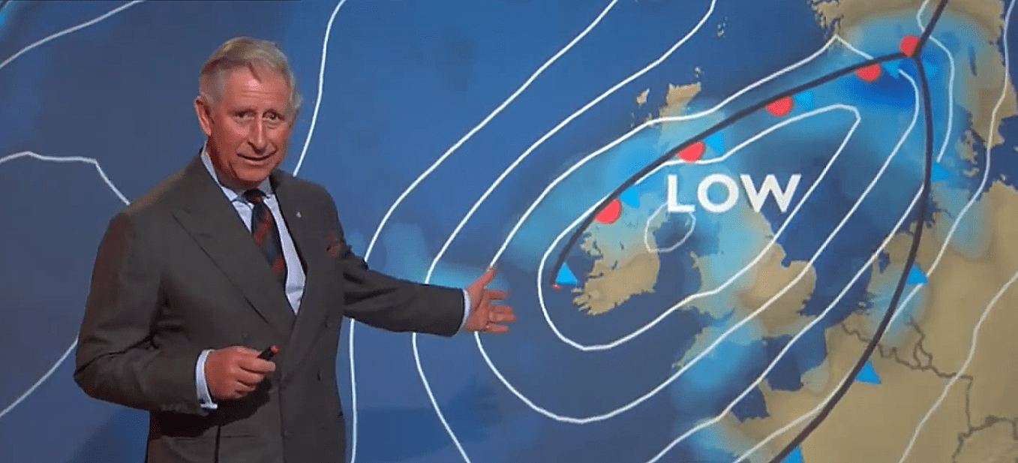 | 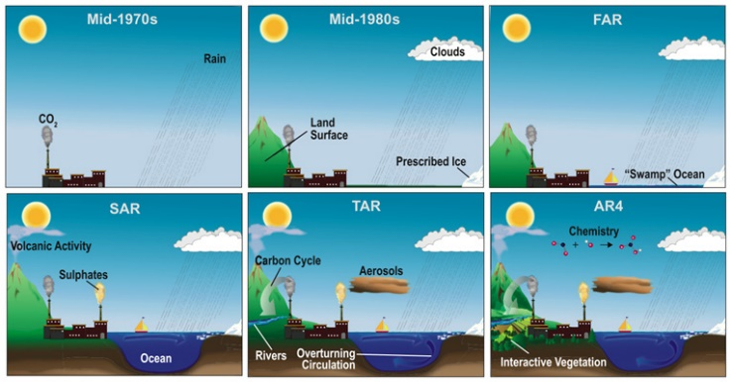
Brief explanation from video | Brief explanation from video | Brief explanation from video

How does uncertainty arise?
- We have incomplete knowledge of the real world - Even our best understanding of processes or the current state of the system may still be wrong.
- Time, money and computer power are limited so models are approximations.
- We often cannot measure everything we need to know so we often cannot measure everything we need to know.
- Even for approximate models we may require further assumptions and all data has error.

......so we often cannot discriminate between competing models.
​(Professor Paul Bates, University of Bristol).

IBDP Geography - Flood mitigation - Part 1: Structural measures​

What is ‘hard engineering?’ | What is ‘soft engineering?’

Method | Building Dams | Channel Modification | Afforestation | Strengthening Levees
Advantages |  |  |  | They can locally protect a community or area from periodic floods if the flood waters stay below design heights.
Disadvantages |  |  |  | Levees cause areas beyond the levees to flood much more than they would if the levee was not built, but creating higher, concentrated velocities;

Evaluation of two measures. The not so good….
Levee Building | Dam Building

IBDP Geography – Freshwater - Flood mitigation Part 2 - Planning

Insurance | Flood Preparation | Flood Warning Tech
Brief summary of the article | Brief summary of the article | Brief summary of the article

Using the embedded article (Task 2), summarise each section of the article in three bullets points, in the space beneath.
‘We could be creating flood risk ghettos‘ | ‘A choice between insurance or putting a meal on the table‘
“The voices of lower-income communities aren’t heard” | ‘We’ve been battered by the government ‘

