IB DP Geography –Types of Volcanoes & Associated Hazards

We will be focusing on the three kinds of volcanoes; shield, composite and cinder. Complete the worksheet below.

Feature | Shield Volcano | Composite Volcano | Cinder Volcano
Diagram | 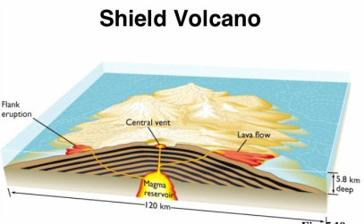 | 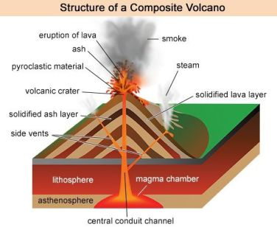 | 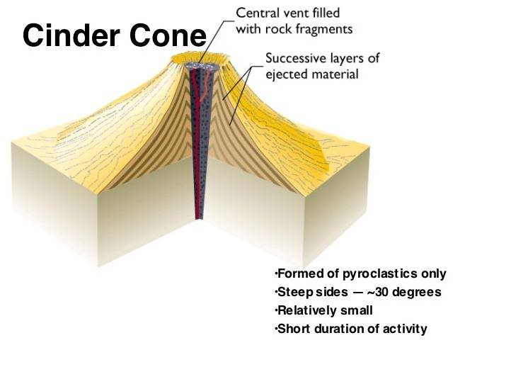
Description of Shape

Link shape to characteristics of lava emitted

Type of eruption (sudden, violent etc.)

Example Place

Type of Eruption | Description | Volcanic Hazards Produced because of Eruptions | Type of Hazard | Photo | Description (inc primary or secondary hazard) | Global Example (place & date)
Lava Eruption | Silica Rich  Runny Basalitic |  | Lahars | 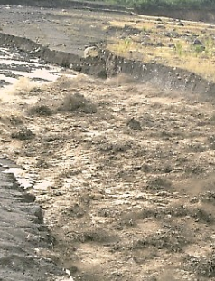
Pyroclastic Eruption | Strombolian Eruptions  Plinian Eruptions. |  | Landslides | 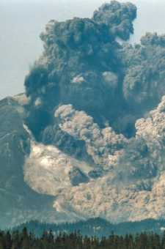
 |  |  | Pyroclastic Flows | 