IB DP Geography – Climate & Solar Radiation Variations

Process | Place
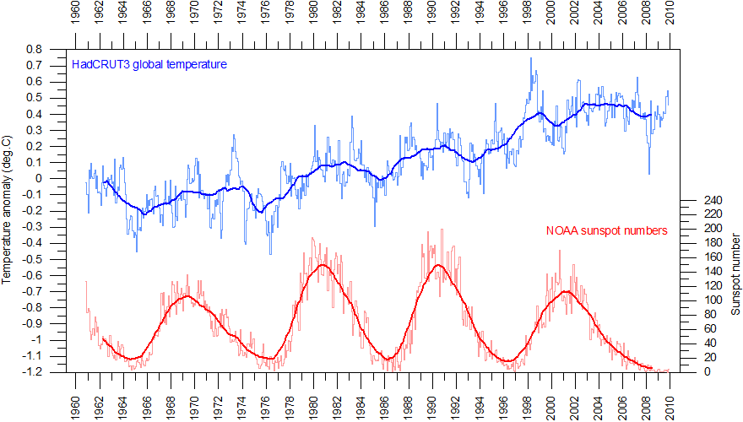

Power | Possibility

Perspectives….

