IB DP Geography – Soil Erosion / Climate Change
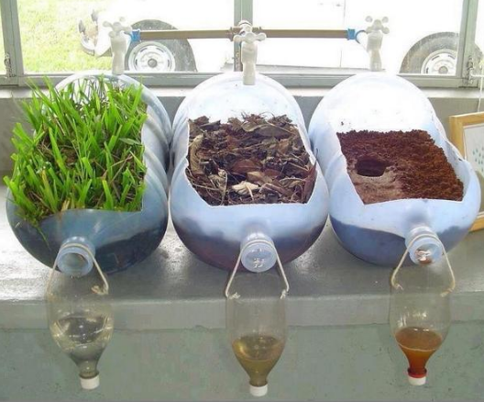

Watch the video embedded on ibgeographypods and take notes on the following questions.

a. Outline then main importance of soil.
b. How is soil formed?
c. How long does it take to form 10cm of soil?
d. How does human activity affect soil erosion?
e. How many tonnes were lost in 2011 & what does that equate to in cost per person and annually to the global economy?
f. How is fertile land being 'grabbed' from potentially vulnerable populations?
g. Why is the issue of soil degradation not "current news"?

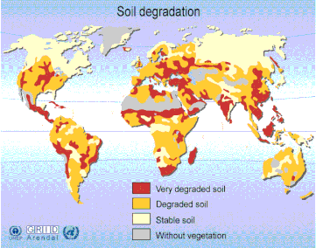

Study the Soil Degradation map above carefully. Answer this IB 5 mark (target 10 minutes) question:

Describe the distribution of global supplies of stable soil and comment on its suitability for future population growth and use.

Watch the first video in the section on Soil & Climate change on ibgeographypods and take notes on how soil erosion is linked to population growth, intensive agricultural activity and carbon storage.
Population Growth

Intensive Agriculture

Carbon Storage

Now watch the second video and make notes on how atmospheric carbon can be transferred back into the soil (flux).

Now study the website for the '4 pour 1000' French government initiative.

Watch the YouTube video embedded on the front page of the site and create a 4 section revision grid and research and extract the four elements of place, possibility, power and process as contained on the site front page.
Place | Power
Process | Possibility

