Part 2 – Circular v’s Linear Economy
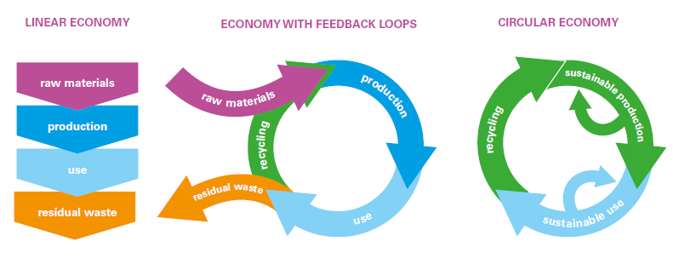

Watch | Read | Listen
www.youtube.com/watch?v=zCRKvDyyHmI | kenniskaarten.hetgroenebrein.nl/en/knowledge-map-circular-economy/how-is-a-circular-economy-different-from-a-linear-economy/ | https://www.bbc.co.uk/programmes/b05r40r7

Key notes from the resources above.
Define Linear -

Define Circular -

Choose an organisation that is making positive progress in adopting circular economy traits. Conduct some research into the company and places it operates and outline how it is moving from a linear to a circular approach. This link will get you started.
Organisation
Outline the project and progress being made.

You will remember the work we did last week on the 17 SDG’s. Please choose three of the seventeen and explain how a circular economy model could help countries to make progress in achieving the goals. Aim to write approximately 100 words for each.
Goal Number & Title
Explanation

Goal Number & Title
Explanation

Goal Number & Title
Explanation

In Grade 11, you will be carrying out a range of CAS activities. Identify a potential school project that could have circular economy links. Remember, there is slightly more to it than recycling paper!

Collaboration Time - Key Questions for Investigation

Working with a partner, each choose a different task (see below) and create a micro presentation to give to them with your response.

You could also work in groups of three.
- Question - Should the circular economy be enforced globally?

- Question - Is it possible to ever prevent the linear economy from existing?

- Creative Task - Everything We Touch - Keep a diary of everything you consume in one day. Check out this website https://www.ph21gallery.com/zuccotti for how this famous artist approached the task. Create a similar display perhaps highlighting the items that have linear / circular characteristics.

