IB DP Geography Freshwater – Salinization (Australia)
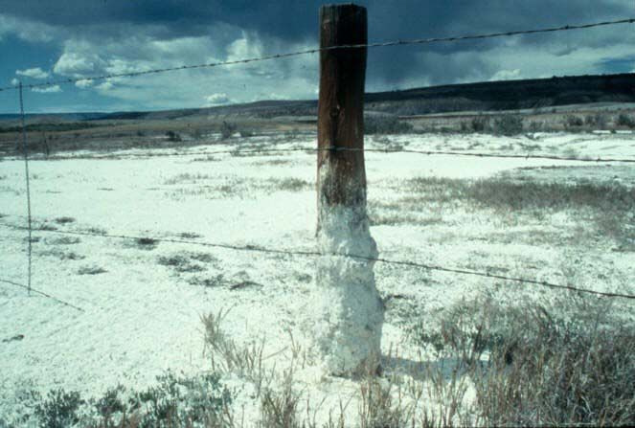
Define Salinization
Soil salinity is the salt content in the soil; the process of increasing the salt content is known as salinization. Salts occur naturally within soils and water.

Using the embedded PDF on ibgeographypods, explain what causes Salinization?
Salination can be caused by natural processes such as mineral weathering or by the gradual withdrawal of an ocean. It can also come about through artificial processes such as irrigation

Salinity from irrigation can occur over time wherever irrigation occurs, since almost all water (even natural rainfall) contains some dissolved salts. When the plants use the water, the salts are left behind in the soil and eventually begin to accumulate.

Salinity in urban areas often results from the combination of irrigation and groundwater processes. Irrigation is also now common in cities (gardens and recreation areas).

Watch the first 1 minute, 30 seconds of the video ‘Salinity and the River Murray’ and explain why the Murray Darling River has become increasingly saline in recent years.
Deep underground there is…

This salty water flows…

Prior to agriculture the area was covered in vegetation that…

By planting irrigated crops…

This has pushed more groundwater into the river making it…

Watch the second video on ibgeographypods. In the space below create a mind map, spider diagram, written report (etc) on the causes and impacts of salinization in this area of Australia.
Part 1 – The shape of Australia. Explain where all rainfall drains to and why.

Part 2 – The vegetation & water table in Australia. Explain how clearing of natural vegetation and irrigation has influenced salinity. Who are the key stakeholders?

Part 3 – How to reverse the problem. Explain briefly here what can be done. Who are the stakeholders?

Part 4 – Impacts on houses and urban areas. Explain the impacts of salinization on urban areas.

Eutrophication & Ohio’s corn and soya bean boom
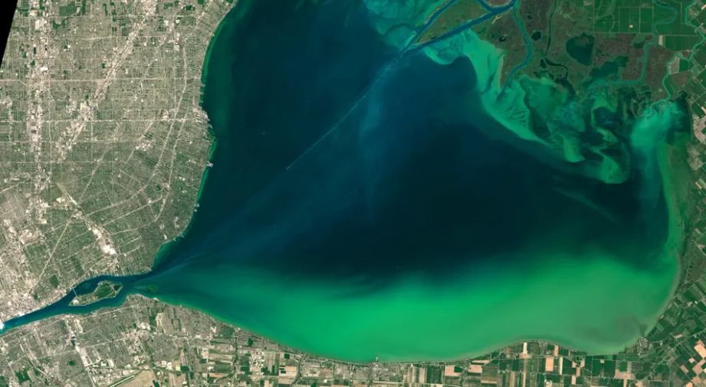
https://www.theguardian.com/environment/2020/jan/04/lethal-algae-blooms-an-ecosystem-out-of-balance
Diagram to show process of eutrophication

Describe the impacts of the algal bloom on Lake Erie (USA).

Describe the likely causes of the algal bloom on Lake Erie (USA).

Identify the key stakeholders in this scenario

