IBDP Geography – River Form & Velocity
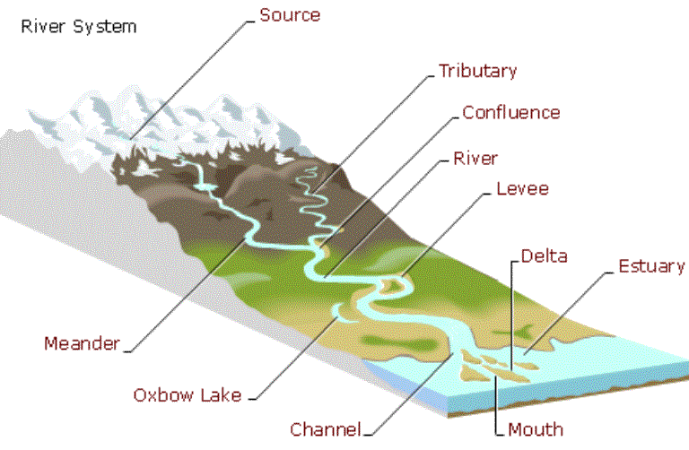
Watch the video embedded on ibgeographypods and take basic notes from the sections on velocity, slope and discharge.
Factor | How it affects the flow / discharge of the river
Gradient

Discharge

Channel Shape

Waugh – Integrated Approach P.68. Define the two types of flow within a river
Laminar Flow
Turbulent Flow

Waugh – Integrated Approach P.68. Draw a sketch to show the features of both laminar and turbulent flow.
Laminar Flow | Turbulent Flow

Waugh – Integrated Approach P.68. What is the relationship between velocity and turbulence and how does this impact on the transportation of the rivers load?
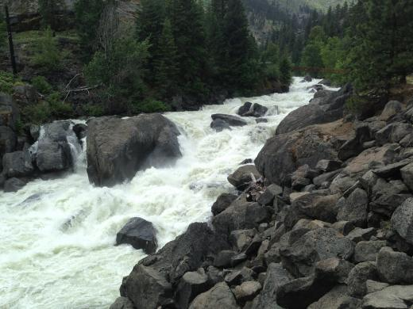

The velocity of a river is influenced by three main factors

- Channel Shape & Cross Section (Waugh – Integrated Approach P.69)
Draw it!
Explain it!

- Roughness of the channel’s bed and banks (Waugh – Integrated Approach P.70)
Draw it!
Explain it!
- Channel Slope (Waugh – Integrated Approach P.70)
Draw it!
Explain it!
