IB DP Geography – Retail Land Use – Case Study Toulouse

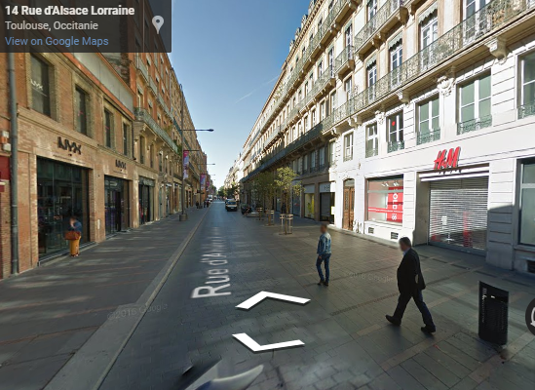

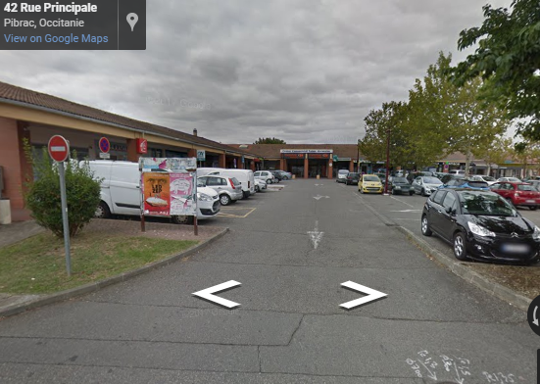

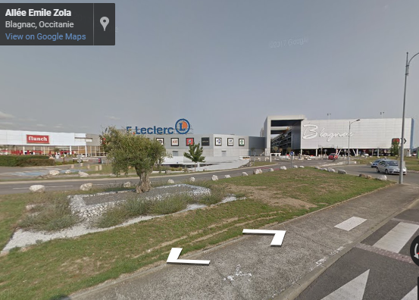

What does high range and threshold refer to when talking about goods offered to consumers?

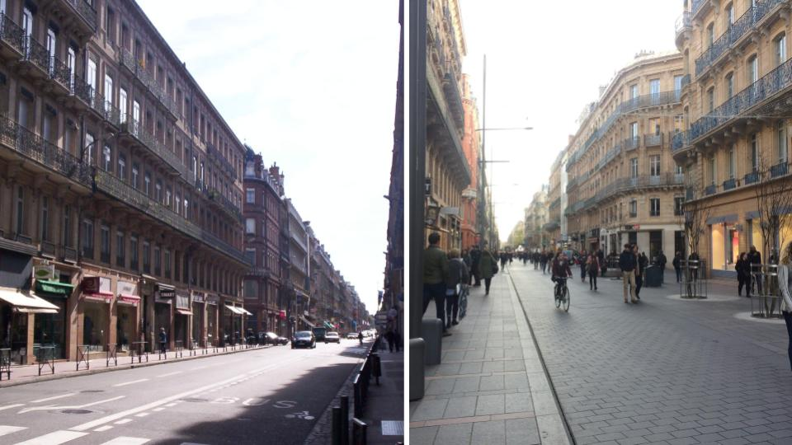

Read the embedded article on geographypods about the refurbishment of rue d'Alsace-Lorraine (on the left in 2006 and on the right now). What has been done to attract customers back to the CBD?

