IB Geography - National trade restrictions – Focus on the USA.
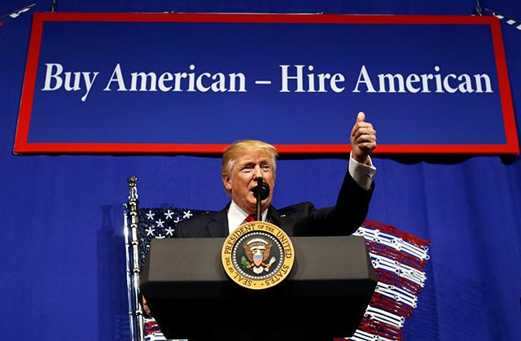

Watch the first video on ibgeographypods and make notes in the table below.
Question | Response
Why do governments put trade restrictions in place?
What arguments can companies make to the government to ask for protection from foreign competition?

How can protecting jobs in one industry lead to job losses in other sectors?

Explain how a tariff on imported goods can lead to an increased revenue for the government.

Explain how ‘The National Defense’ argument works?

Now watch the second video on the steel tariffs being imposed by the USA on foreign steel and make notes in the space below.

What is does a ‘trade deficit’ mean?

Why
What

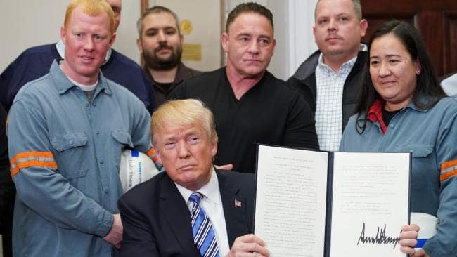

When
Who

How could these measures taken by the Trump administration be considered as protectionist?
Define Protectionist: an advocate of the policy of shielding a country's domestic industries from foreign competition by taxing imports

Explain how these measures could lead to ‘resource nationalism' by reading this news article embedded on ibgeographypods.
Define Resource Nationalism: is the tendency of people and governments to assert control over natural resources located on their territory.

