IB Geography – Patterns of Oil Consumption & Production

Study the two inflated/deflated maps below. One Shows Crude Petroleum Exports. The other shows Crude Petroleum Imports

Which one is which? Use evidence from the maps and your own knowledge and understanding to explain the differences making reference to specific regions and distortion.

Title: _________________________________________________

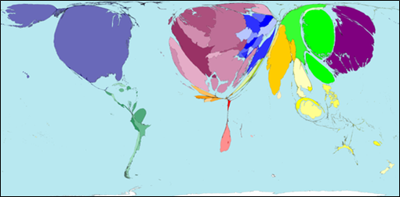

How do I know this? Refer to at least three places / populations / level of development.

Title: _________________________________________________

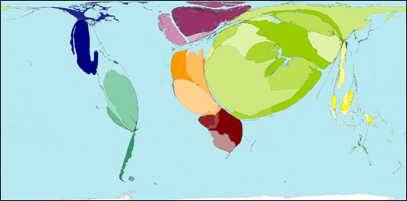

How do I know this? Refer to at least three places / populations / level of development.

Rank | Top Oil Producing Nations | Rank | Top Oil Consuming Nations
1 |  | 1
2 |  | 2
3 |  | 3
4 |  | 4
5 |  | 5

Oil Producing Nations - Is there a pattern in terms of geographic location?

Oil Consuming Nations – Comment on disparities between the consumers and what they produce?

Advantages of Fossil Fuels | Disadvantages of Fossil Fuels
1  2  3  4  5 | 1  2  3  4  5

Key piece of information from this lesson

