IB Geography – Factors Affecting Participation in Sports & Tourism

High Relief & Cold Temperatures | Physical  Factors  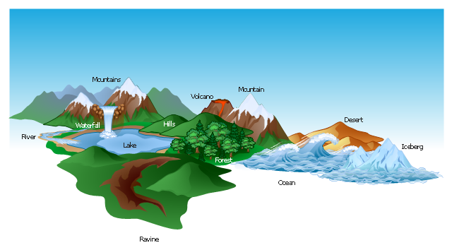 | Rivers
Exposed Coasts |  | Coastal & Hot
High Relief Areas |  | Lakes

Identify well-known places where the six physical factors above determine the location of sports and tourism. Name the location name e.g. The Pyrenees and the associated activity e.g. skiing.

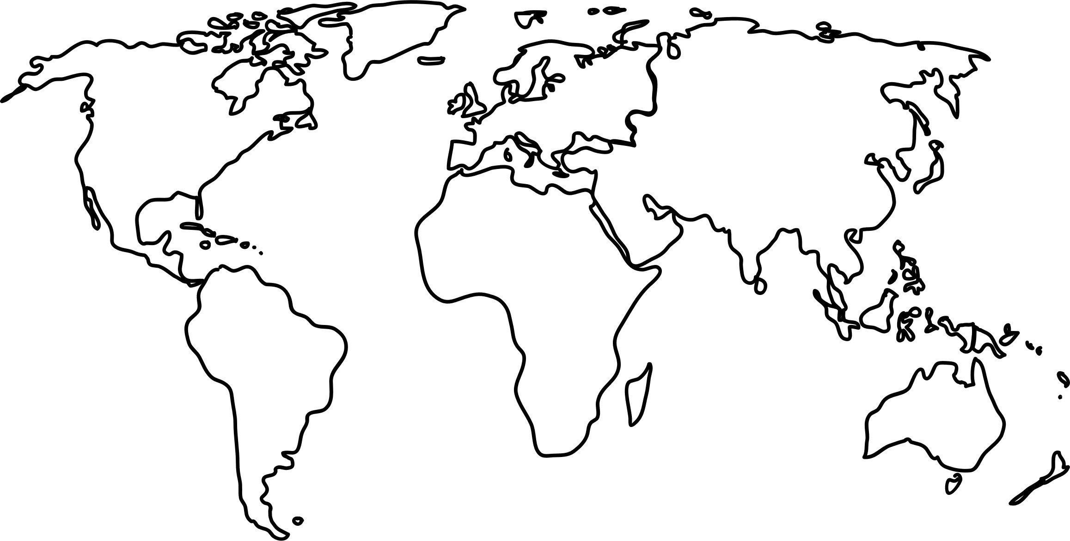

Key

