|  |
| --- |
| **IB DP Geography – Modelling Urban Areas** |

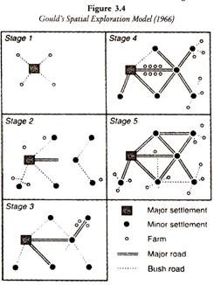

|  |
| --- |
| Study Gould’s Spatial Exploration Model (1966) above. Explain how the growth of settlement happens according to this model. |
|  |

|  |  |
| --- | --- |
| **Model** | **Explanation of growth** |
|  |  |
|  |  |
|  |  |
|  |  |