Sustainable Development Goal – Personal Cubes (A3 size - card)
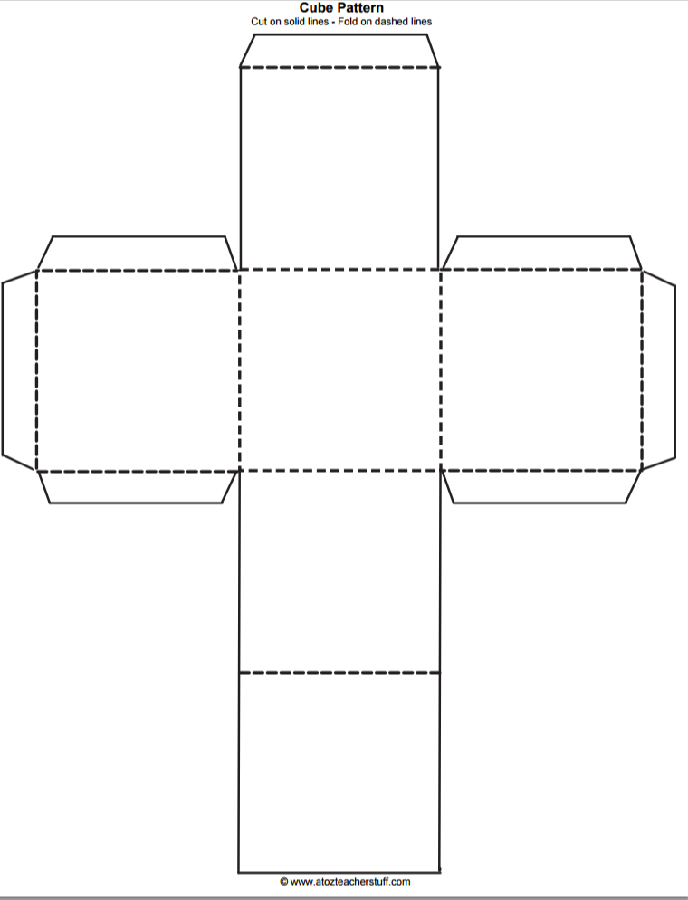
To be used in conjunction with
http://www.ibgeographypods.org/sustainable-development-goals-2030.html
Face 1: Logo & title of SDG
Face 2: Which places are affected by this goal & why?
Face 3: Which processes are causing the issue?
Face 4: Which groups have power over the goal being achieved?
Face 5: What are the possibilities targeted by the goal by 2030?
Face 6: Summarise a recent news story that has clear links to this goal.

