IB Geography - ib
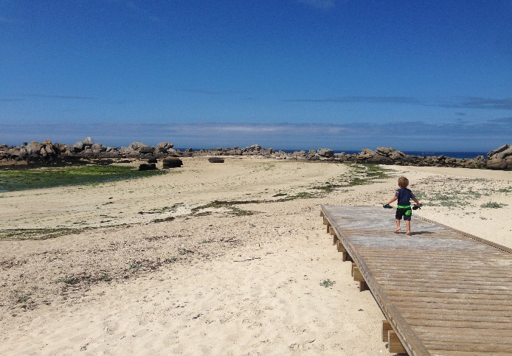
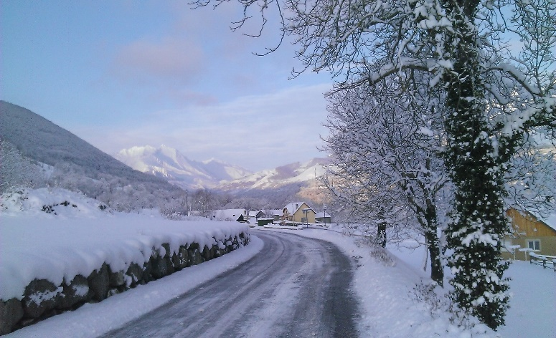

A Primary
Tourist Resource
A Secondary
Tourist Resource

Plot the new and exciting tourist activities onto the map below with a brief annotation to show what the activity involves (primary / secondary resource)
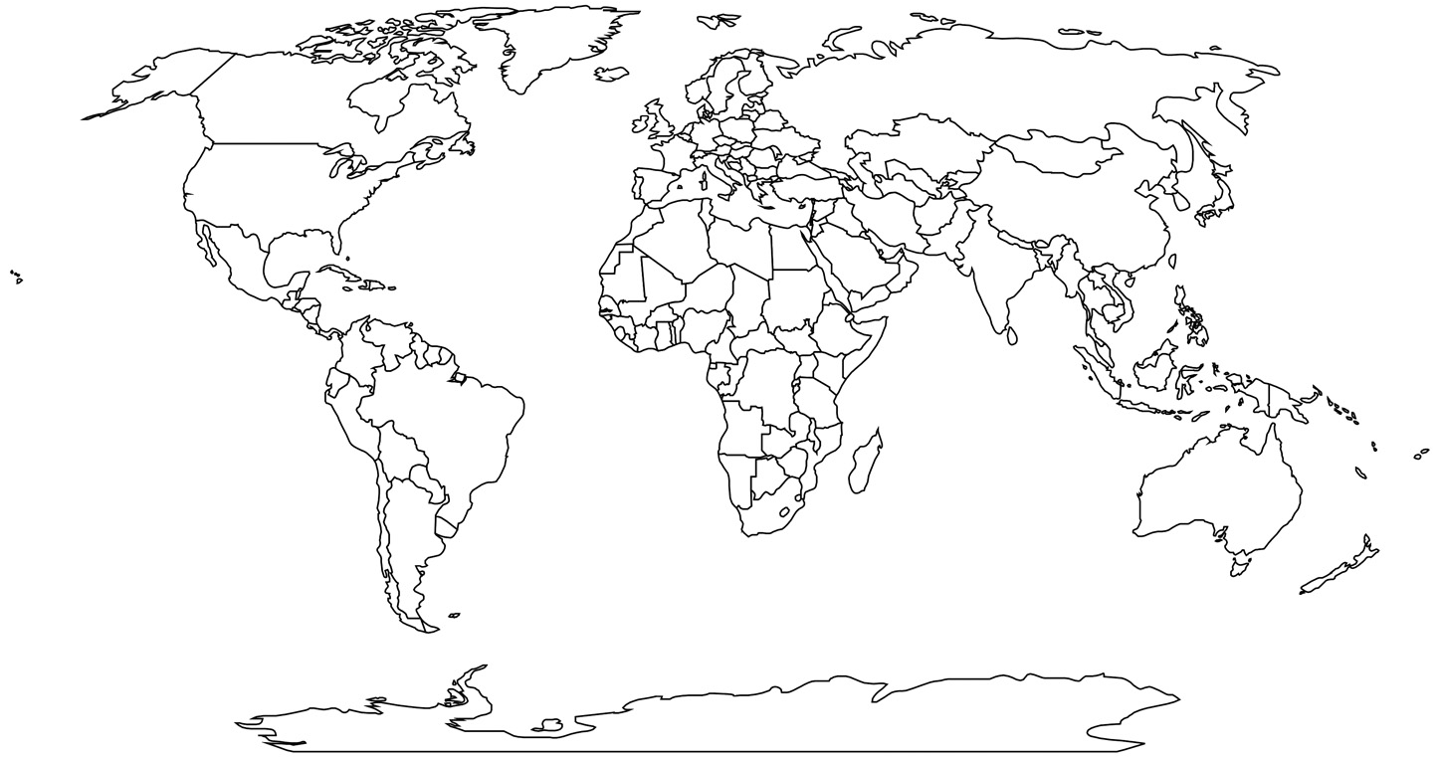

Watch the video (with the music turned down!) and make a note of the characteristics of each type of tourism.
Type | Description | Example place in the world.
Adventure
Cultural
Religious
Medical
Eco
Heritage
Epicurean (food & drink)
Educational

Type of Tourism | Definition
High End Tourism
Budget Tourism
Mass Tourism

High End Tourism – Mini Case Study – Discover The World LTD Ice Hotel Sweden
Cost | 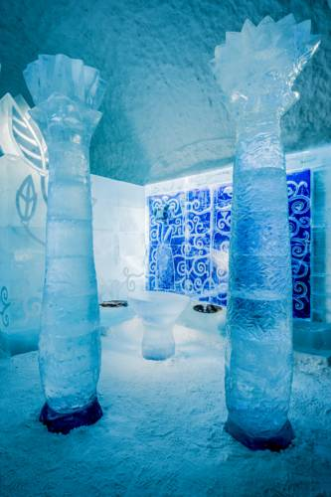 | Activities
Duration

Transport

------------------------------------------------------------------------------------------------------------------------------------------

Budget / Mass Tourism – Mini Case Study – Jet2 All Inclusive to Ibiza
Cost |  | Activities
Duration

Transport

