IB Geography – Introduction to Changing Leisure Patterns

Using the TEDX video on ibgeographypods, take notes on how leisure trends have changed in the following decades:
What does 8760 represent?
1950’s
1960’s
1970’s
1980’s
1990’s
2000’s

How do we spend our time now (note this video is from 2012). How has TV taken more steps forward since then?

Define Leisure
Define Recreation
Define Sport
Define Tourism

Leisure & me | Recreation & me | Sport & me
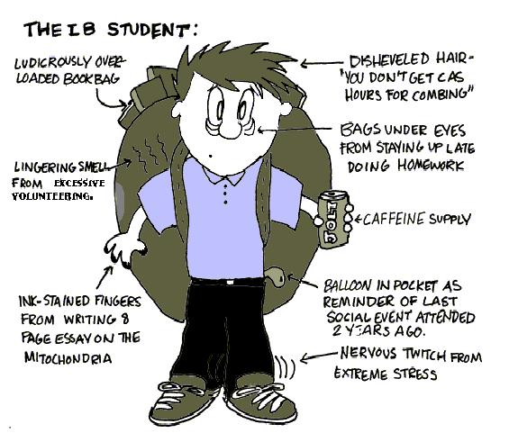

Sport & me | Personal care & me | N° of hrs per week dedicated to leisure, recreation, sport?

As a small group, discuss and record down your thoughts to the question below.
Do some people enjoy carrying out domestic (non-leisure) activities. What about cooking?

Is there such a thing as ‘free time’? Or do social and economic forces package it as "leisure time" and offer you a host of (paid for) activities.

If you have a free weekend, what sort of things might you do?

How is this activity presented to you?

Why do you feel it is leisure?

Why do many HIC governments like to promote Leisure Time amongst their populations? Surely, a person not at work is not economically productive?

IB Geographers On Tour - Mapping My Travels

Use the link on ibgeographypods to complete your travel map of the world. When you have completed it, you can take a screen shot and paste it into the space below.

Study your travel map above and compare the results to others in your class. In the space below, write about your pattern of global travel and what / who has influenced it.

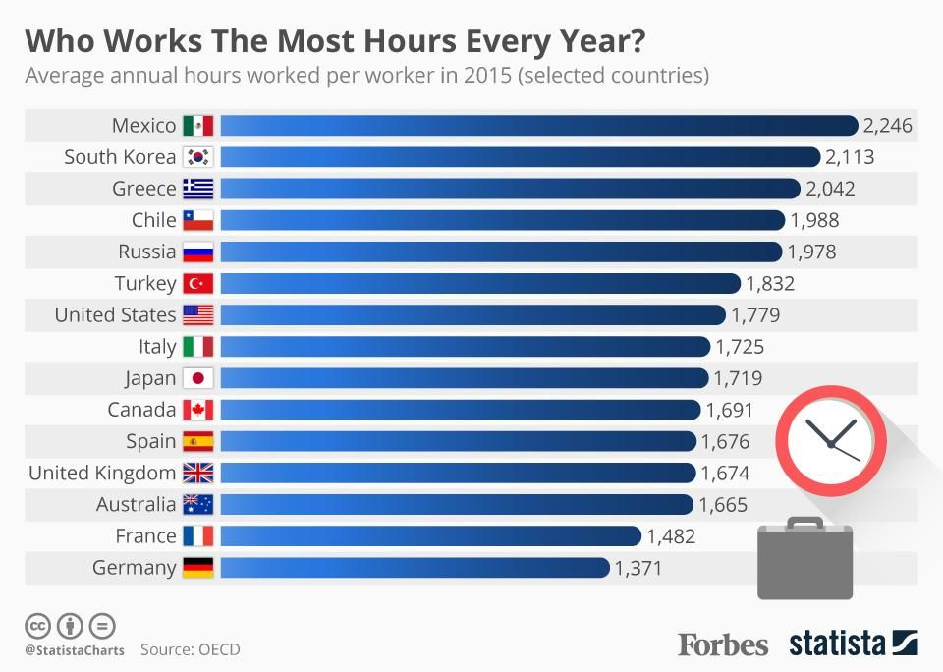
On average, how many more days per year does a Mexican work than a German?
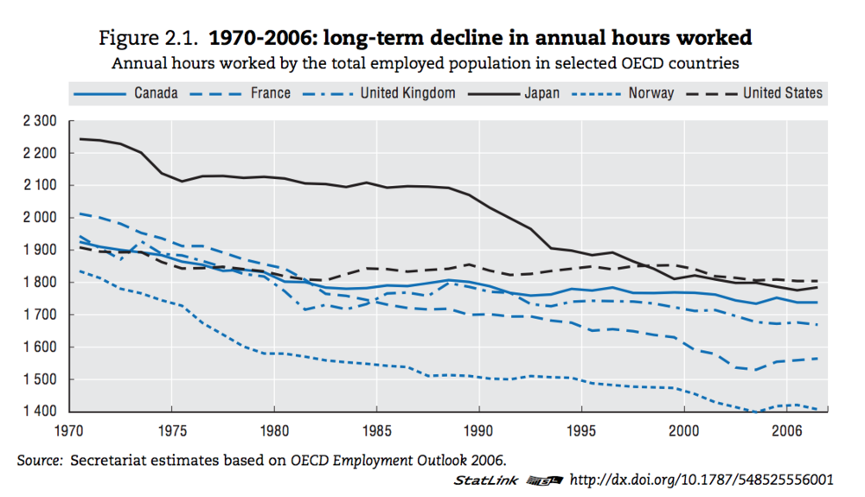

Discuss why OECD countries have more access to leisure than L/MIC’s.

Using this link, compare and contrast Denmark (top) and Colombia (bottom) from the 37 mostly affluent nations from the Organisation for Economic Co-operation and Development

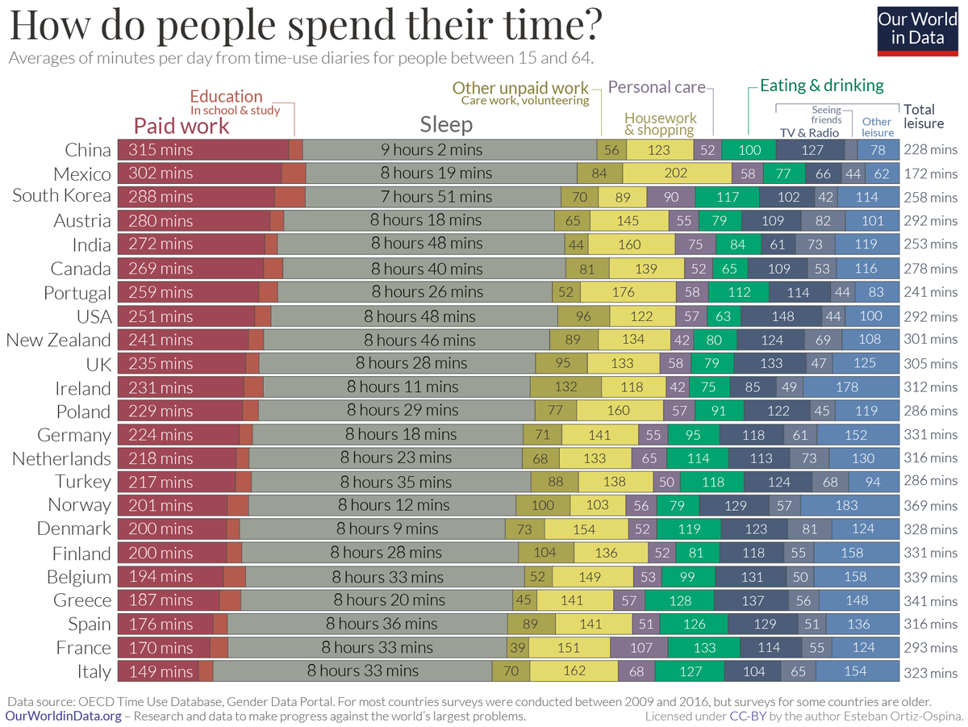

Write a short commentary comparing leisure time in France & China.

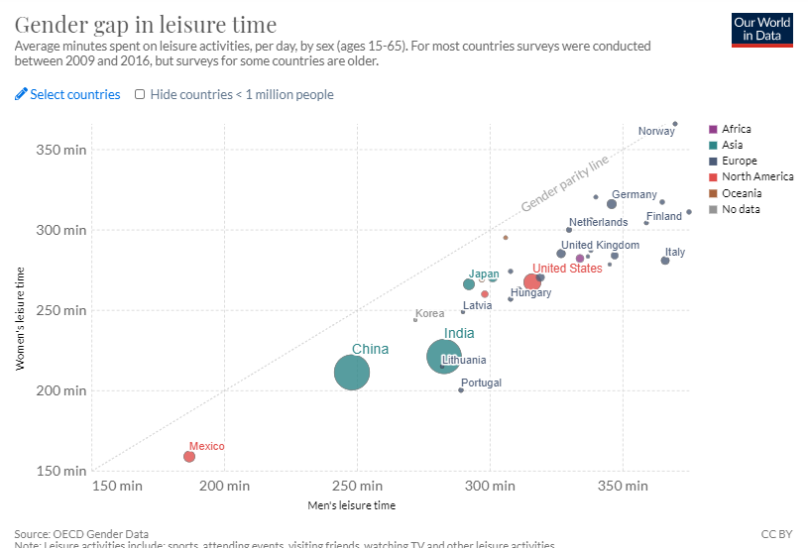

Using the chart above (source here), describe the gender gap in leisure time globally.

