IB DP Geography – Water Issues & Water Scarcity – An Introduction
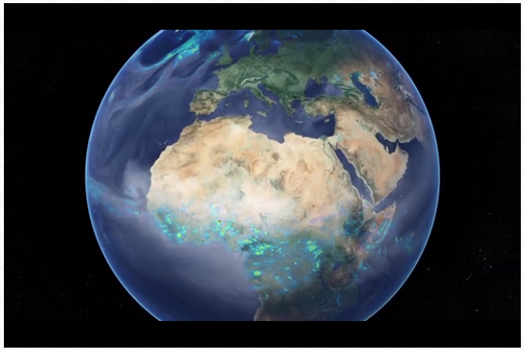

Task 1 – Watch the video embedded on the website and make notes on the content as follows…

- What is the link between access to freshwater and growth of human populations?
- How are humans through to be altering the global water system?
- Approximately how many large dams are there ?
- Approximately what proportion of global wetlands have been drained?
- What is the comparative area used to grow crops worldwide?
- What is the comparative area used to rear livestock worldwide?
- Outline some of the future effects of human activity on the global water system.
- Outline the effects of water shortage and alterations to drainage basins on humans.
- Which of the SDG’s do these issues relate to? (may be more than one).

Task 2 – Watch the second video on the website and take notes on the causes and effects of the two different types of water scarcity.

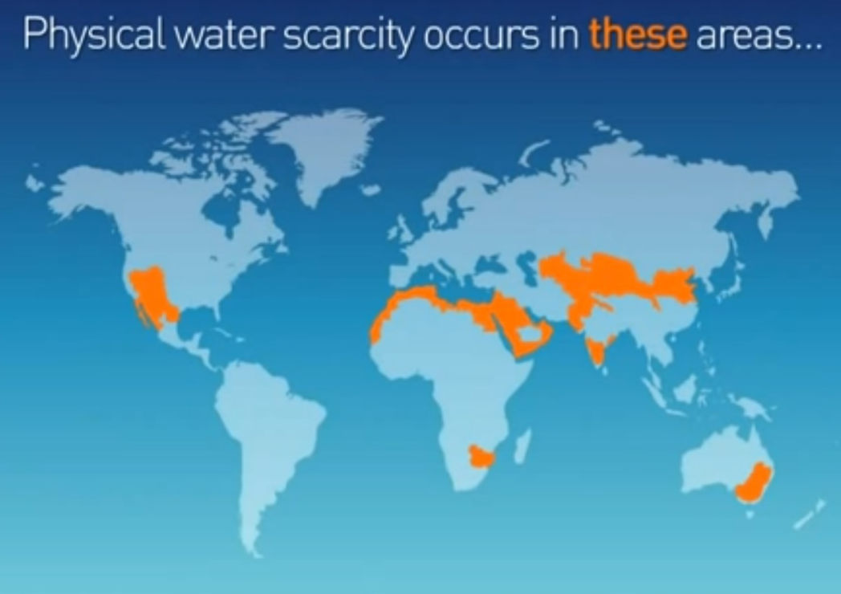
Physical Water Scarcity

Economic Water Scarcity
