IB DP Freshwater (Option A) – The Importance of Wetlands
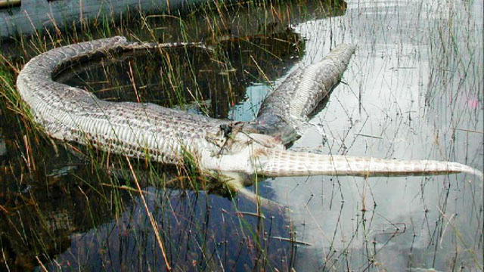
What happened in the picture above?
Task 1 – Using the web link on the ibgeographypods.org, create a summary of the value of wetlands in the table below. You should aim for a 50-word summary of each.

Factor | 50 word summary of the importance.
Shock Absorber

Carbon Store

Biodiversity

Products & Livelihoods

The Nimmie Caira Project – New South Wales (Australia)
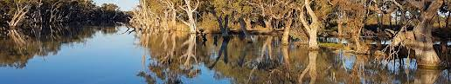

What is the Nimmie Caira?
Nimmie-Caira is part of the Lowbidgee floodplain, the largest remaining area of wetlands in the Murrumbidgee Valley within the southern Murray Darling Basin. This floodplain and its associated wetlands systems are areas of national and international significance. They provide feeding and breeding habitat for many waterbird species, including colonially breeding water birds and migratory species, listed under international agreements, rare and endangered frogs and birds, as well as threatened plants.

Task 2 - Using the resources on ibgeographypods, create some 'detailed example' notes that outline the pressures Nimmie Caira and the subsequent efforts to protect them, including the future possibilities for the area.
Pressures on the Nimmie Caira | Efforts to protect the area

