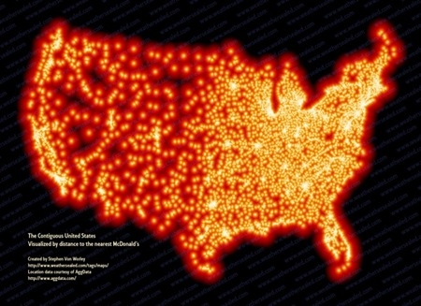**IB Tokography – Add a suitable title to each then annotate what you see …..**

**[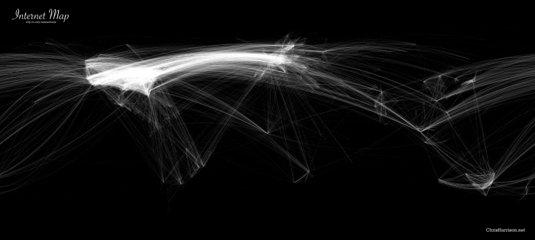](http://www.chrisharrison.net/projects/InternetMap/)**

Annotate features

Country:

