IB DP Geography – Urban Environments (Option G)
Causes and Responses to Congestion & Air Pollution in Paris, France.
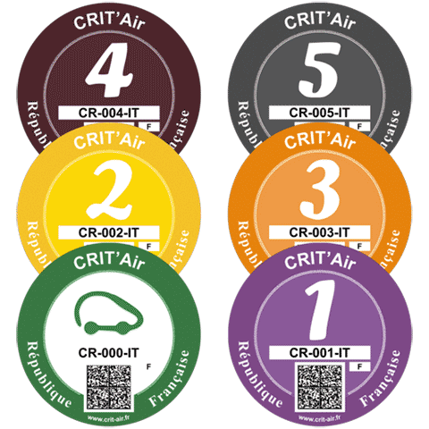
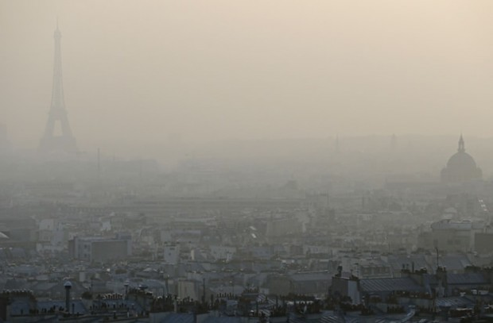

Background Task - Congestion – Take notes from the first 12-minute video from FRANCE 24 on the causes, impacts and possible responses to severe congestion in Paris. Pay attention to the arguments on both sides.
Background Task – Air Pollution. Take notes from the National Geographic video on the website. Pay particular attention to the links between climate change and global warming (link to Perspectives).

Task 1 – Click on the website link to be taken to some headline statistics on traffic congestion in Paris for 2016. Make a note of some of the major findings (in terms of % of extra travel time).

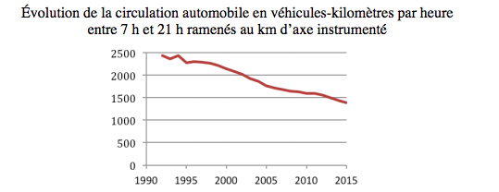

Task 2 - The graph above shows Vehicle-kilometers per hour, between 7 am and 9 pm, in “intramural” Paris, since 1990. (Fréderic Héran). Does this suggest that congestion has therefore reduced since 1990?

Task 3 – Watch the first video (in French) and make notes on the ‘physical’ causes for the poor levels of air quality in Paris at certain times of the year.

Task 4 – How does the ‘heat map’ of Paris embedded on the site help to support what the main cause of air pollution is?

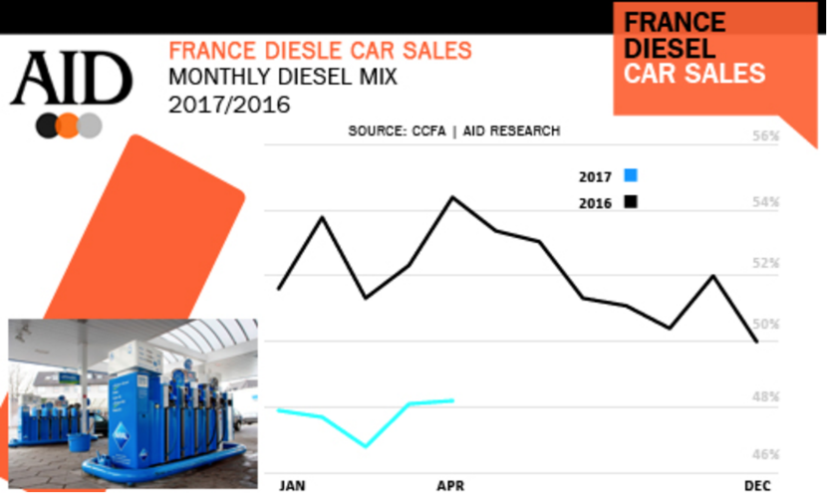

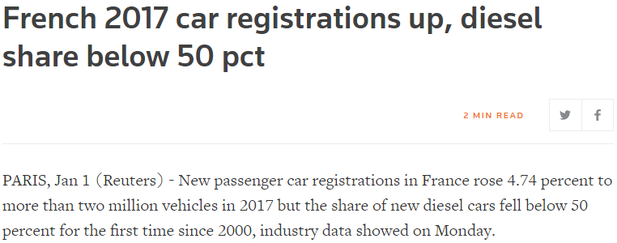

Task 5 – What does the graph suggest about the impact of the new laws on the type of car people purchase in France?

Scheme 1 – Reducing Air Pollution, Paris.
Task 6 - Complete the sections here from the resource bank on the website.
Scheme
Power | Process
Possibility | Place (exactly where in Paris)
Pros | Cons
Evaluation of likely success & sustainability of the scheme
Scheme 2 – Reducing Air Pollution, Paris.
Task 7 - Complete the sections here from the resource bank on the website.
Scheme
Power | Process
Possibility | Place (exactly where in Paris)
Pros | Cons
Evaluation of likely success and sustainability of the scheme

