IB DP Geography Urban Environments – Urban Microclimate
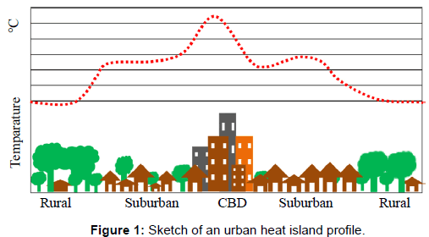
Task 1 – Define a microclimate

Task 2 – Explain briefly the Urban Heat Island Effect making reference to the image at the top of this page.

Task 3 – Using the information on page 15 of the embedded PDF document on ibgeographypods, complete the key data to show the impact of the urban heat island effect.
Weather Element | Urban Heat Island Effect
Sunshine Duration
Annual Mean Temperatures °C
Total Precipitation
Number of Rain Days
Number of Days with Snow
Amounts of Condensed Nuclei

Task 4 - You are now going to look at how and why the microclimate can be impacted using the Met Office’s example of London within the PDF. You task is to make a 50 word spider diagram summary of the causes and effects around each visual below.

Urban Temperature Impacts

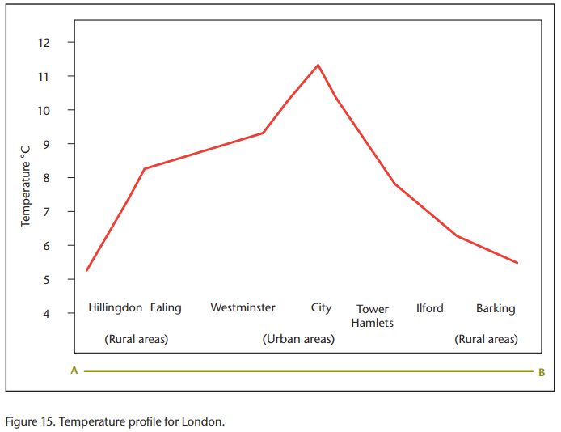

Urban Precipitation Impacts

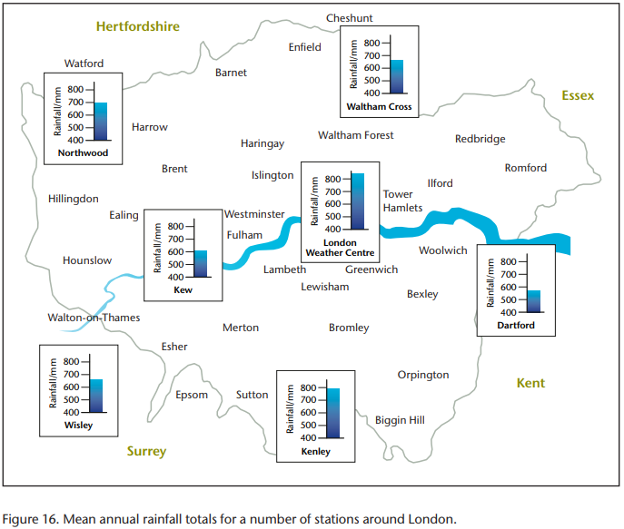

Urban Smog Impacts

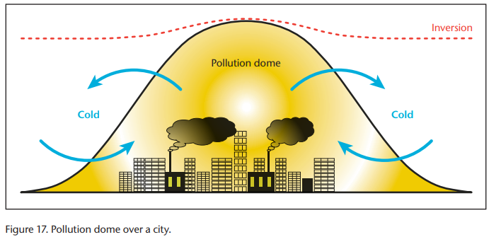

Check out this Met Office video to learn about a temperature inversion. To put this into context, you may see this in winter in the mountain valleys where all the smoke from wood burning chimneys forms a layer at the bottom of the valley. This photo shows that process in action over an urban area.
Urban Wind Impacts

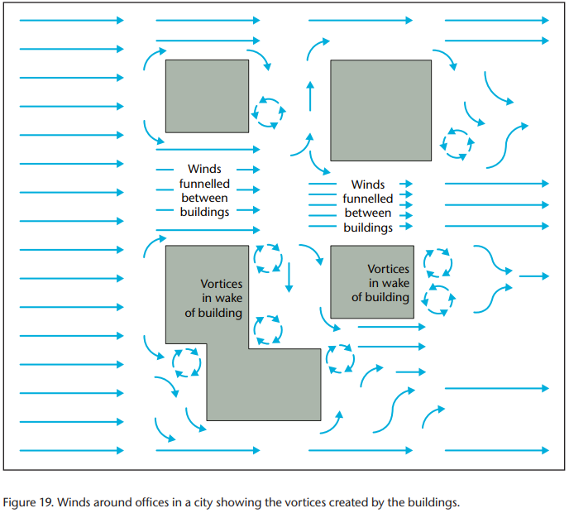

Extension activity – Check out this amazing 10 minute video to see how a design fault in a building in Leeds (UK) caused people to be blown off their feet!
https://www.youtube.com/watch?v=Y0PVrGZGbRA

