Geopolitical constraints on global interactions – Great Firewall of China
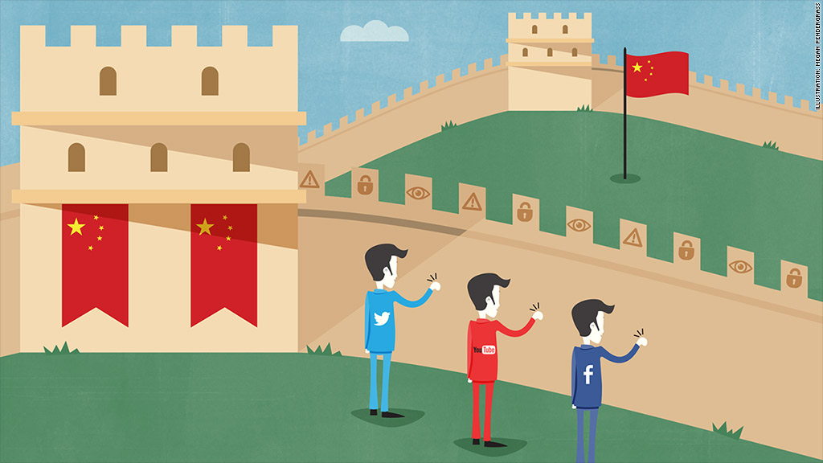
Banned Online Providers | Allowed

How many online users in China?

Process | Power
Place | Possibility

Case Study 2 - Eritrea

Watch the video embedded on geographypods. Explain how the government and the military censor global interactions within the country and the effect that this is having (migration, imprisonment etc).

Explain how the Eritrean diaspora community are fighting against this censorship.

