IBDP Geography - Carbon stored in ice, oceans and the biosphere

Part 1 – Melting Glaciers

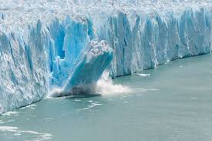
What is a glacier?

Notes on the amount of organic carbon stored in glaciers and how it is ‘biological mobile’.

Impact on economic activity

Three key pieces of information from the hyperlinked article.

Part 2 – Ocean Acidification

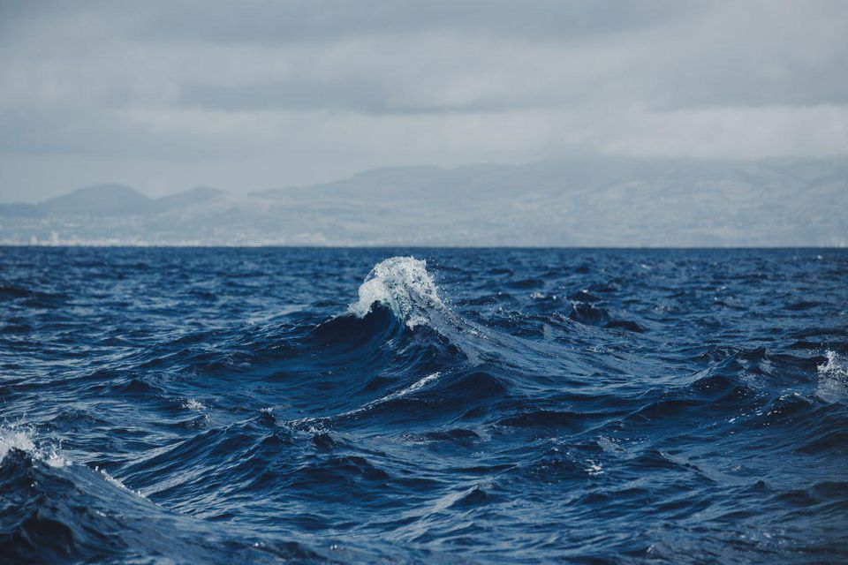
Define Ocean Acidification

First Video – What is the Atlantic Meridional Overturning Circulation?

Second Video – What happens when the ocean warms? Outline the key issues below.

Three key pieces of information from the hyperlinked articles.

Part 3– Biosphere

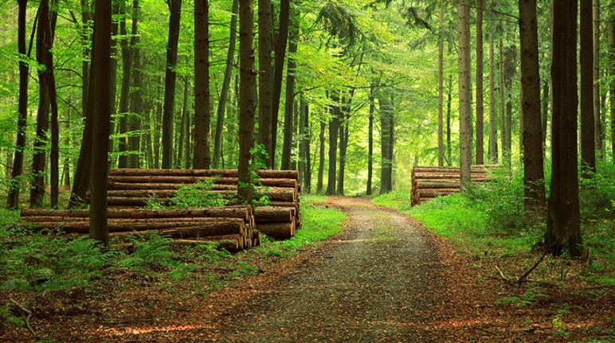
Define Biosphere

First Video – Explain how trees capture carbon from the atmosphere and the impacts of rapid deforestation. Make reference to at least three places in your notes and forest loss there.

Second video – Outline who REDD are, why they were set up and what they aim to do. What are the criticisms of the scheme.

Using the Guardian article, outline what the ‘climate triple whammy refers to’.

