IB Geography – Hazards & Disasters
Case Study Summary Sheet for Freetown Landslide, Sierra Leone (LIC)

Where did it happen?
Freetown is the capital and largest city of Sierra Leone. It is a major port city on the Atlantic Ocean and is located in the Western Area of the country. Freetown is Sierra Leone's major urban, economic, financial, cultural, educational and political centre, as it is the seat of the Government of Sierra Leone. The population of Freetown was 1,055,964 at the 2015 census. Freetown's topography alternates between thickly wooded and partially deforested mountains. The construction of large homes in hillside areas and unrestricted deforestation for residential purposes weakened the stability of nearby slopes and caused soil erosion.
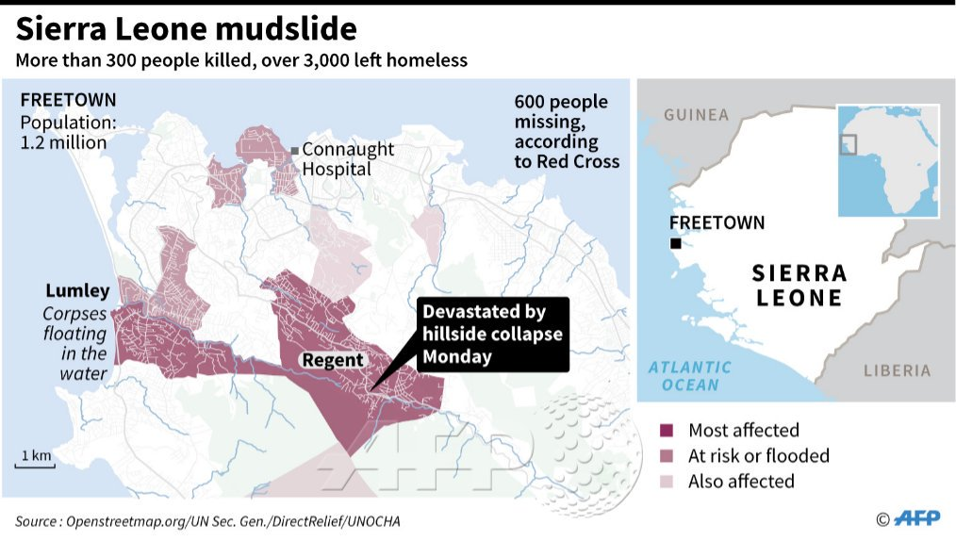
Geo Fact Box – Sierra Leone Need To Know
Indicator | Values (2017 estimated)
GDP per capita PPP | $500
People Living in Poverty (less than $2 per day) | 60% of the population
Access to Clean Water | 50% of the population
Life Expectancy | 52 years
Literacy Rate | 48%
People Per Doctor | 0.05 doctors per 1000 people

When did it happen?
Date. 14 August 2017 AM
Duration. Rapid onset mudflows following three days of torrential rainfall in the area.
Why did it happen?
There were a combination of factors responsible for the mudslides include the region's particular topography and climate – with Freetown's elevation close to sea level and its greater position within a tropical monsoon climate. Those factors were assisted by the generally poor state of the region's infrastructure and loss of protective natural drainage systems from periods of deforestation. Within Freetown, there are many unorganized settlements and municipal works encroached on to the flood plains, resulting in narrower water passageways. During floods, Freetown's drainage systems are often blocked by discarded waste, especially in the city's poorer communities, contributing to higher levels of surface runoff (Note link to Option A). According to the National Weather Service's Climate Prediction Center, Sierra Leone experienced a particularly wet rainy season, with the capital city of Freetown, in the Western Area of the country, experiencing 104 cm of rainfall from July 1, 2017, leading up to the mudslides – nearly tripling the area's seasonal average.
Who was affected by it happening?
Social Impacts | Economic Impacts
1141 people dead or still missing.  Damage to hundreds of homes  3000 people left homeless and moved to emergency camps.  Accessibility between communities was lost due to cutting of communication routes.  Unsanitary waters raised fears of cholera; however, aid workers provided storage tanks, purification tablets, and instructional courses on hygiene to help prevent an outbreak of waterborne diseases | Roads, bridges and footpaths blocked or washed away. Total damage to communication routes affected totals $1 million.  Power outages in many communities caused by the deliberate cutting off of supplies in order to avoid electrical accidents.  After the disaster, affected areas faced water shortages; as a result, UNICEF distributed 26,000 liters of drinking water each day
Environmental Impacts | Political Impacts
Loss of agricultural productivity  Loss of biodiversity  Changes to river drainage patterns of the surrounding area.  Sedimentation of many rivers and streams as well as the pollution of surface water storage by mud and sewerage. | President Ernest Bai Koroma addressed Sierra Leone in a national broadcast August 15, declaring a state of emergency and announcing the establishment of a relief center in Regent. He urged the nation, still recovering from the aftermath of the Ebola outbreak, to remain unified.  Aid donations from China, UK, Spain, Ireland, Israel. The World Food Programme (WFP) provided rations for 7,500 people. The European Union authorized €300,000 for humanitarian aid

Impacts of these hazards on different aspects of human well-being
Health | Shelter
Food | Water

