IB DP Geography – Contemporary Dam Building Project – Ethiopia
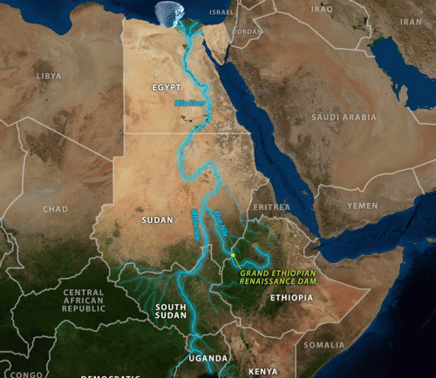
Background Information on the scheme and why this ‘Place?’

*Total Predicted Cost:
Why a multipurpose scheme? Give details of each ‘Possibility’.

Ethiopia (Place) | GDP PPP | Life Expectancy | Literacy Rate | KOF globalization rating
 | 2000  2010  Now | 2000  2010  Now | 2000  2010  Now | 2000  2010  Now

Country Impacted | Social Impacts | Economic Impacts | Environmental Impacts | Political Impacts
Ethiopia
South Sudan & Sudan
Egypt
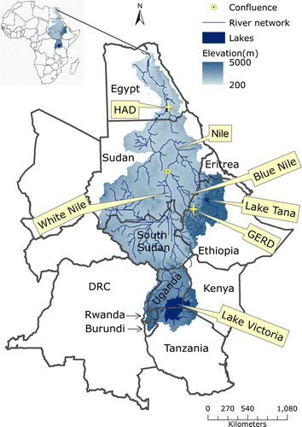
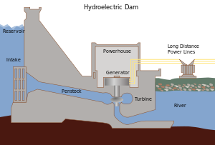
Explain how hydroelectric power can be produced by dams and reservoir. Use the diagram to the left as your starting point.
3 Key Pieces of Data
1
2
3

