IB DP Geography – Option A Freshwater - Key Controls in a Drainage Basin
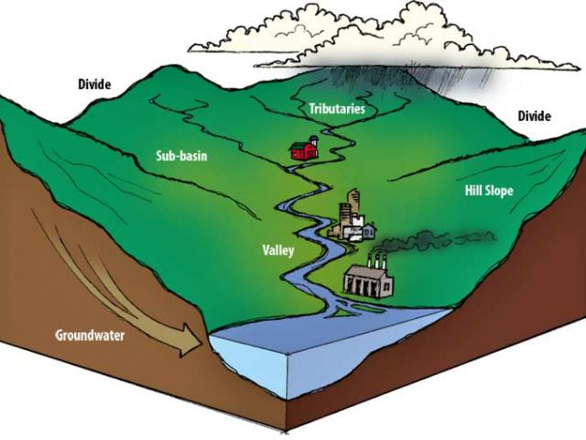
These eight controls should not be viewed in isolation to one another. It is rare that just one of these control mechanisms would contribute towards a major event in a drainage basin. They should therefore be viewed as an interacting set of factors (systems thinking) that contribute towards the behaviour of the basin.
Drainage Density
Soil Type
Land use
Type of precipitation
Tides & Storm Surges
Geology
Temperature
Size & Shape

