IB Geography – Distribution of Mass Movement Events

Starter: Watch the first video embedded on geographypods, and note the links between the eruption and subsequent potential landslide on La Palma. This links a number of hazards that you have already studied.

Using the embedded NASA video on geographypods and the two screen shots below, make a note of:

1. Seasonal landslide events linking to well-known precipitation led events. You can annotate the maps below to show these events.
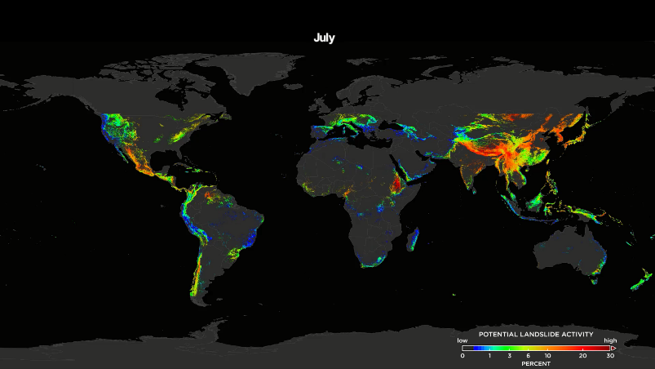

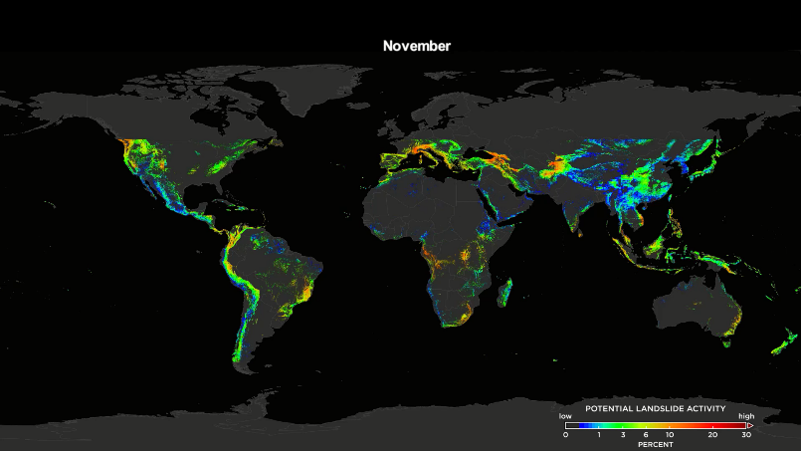

Using the embedded NASA video on geographypods, make a note of:

2. The link between landslide events and plate tectonic movements (particularly those involving the formation of fold mountains).

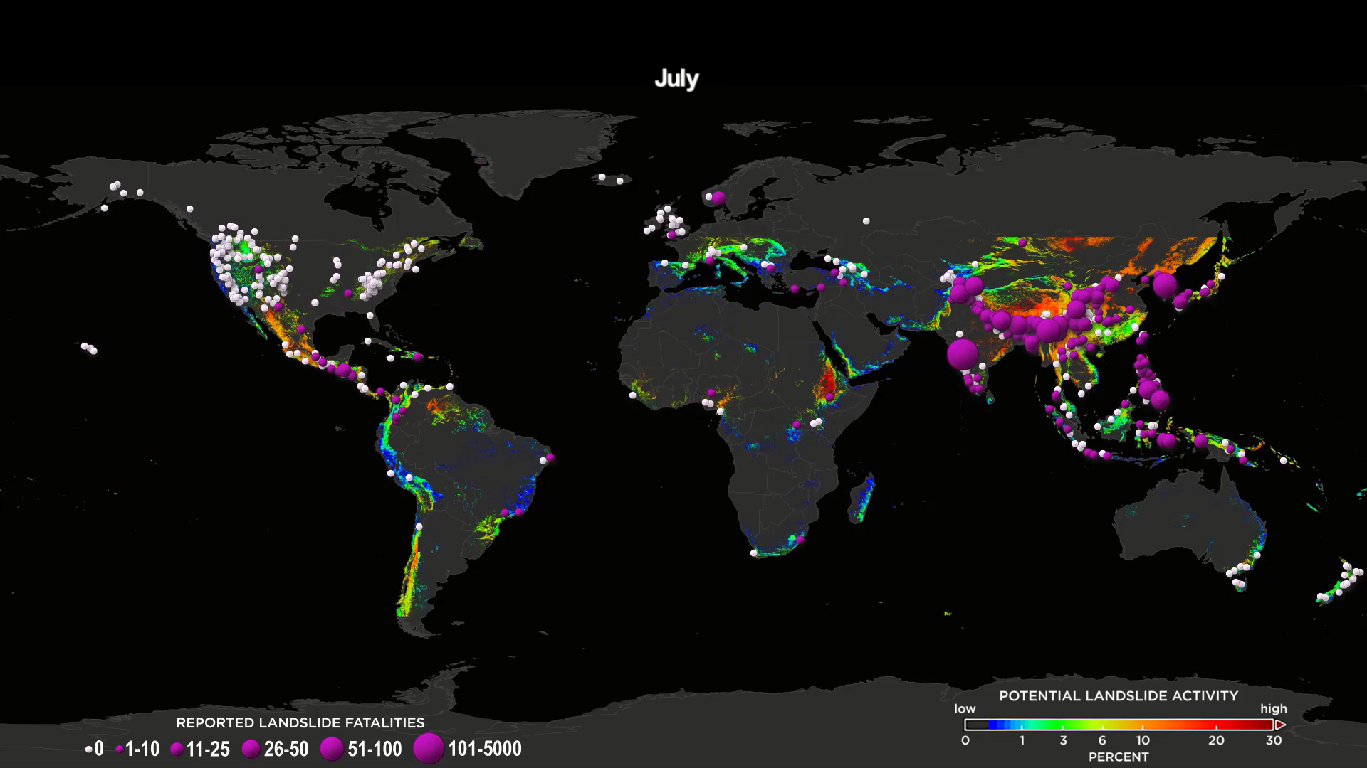

Using the NASA map above from 2007,

1. Comment on the relationship between plate boundaries, mass movements, monsoon events and population distribution as contributing factors to death rates.

