IB DP Geography – Physical Risks to Supply Chain
Case Study Coronavirus – China
Key Definitions
Supply chain is defined as a “network between a company and its suppliers to produce and distribute a specific product to the final buyer. This network includes different activities, people, entities, information, and resources.”(Investopedia).
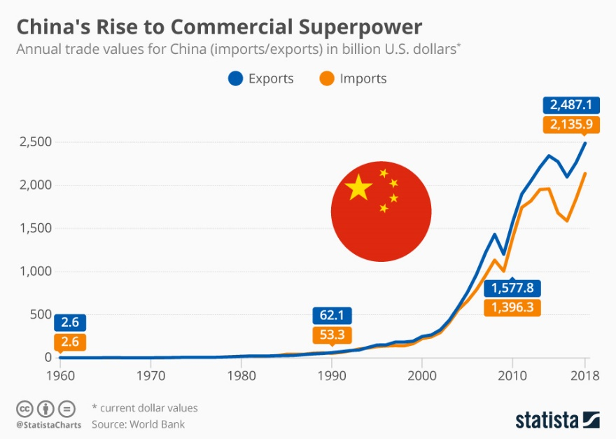

Use the chart above to explain the potential significance of the coronavirus on Chinese manufacturing and exports.

Define the term ‘pandemic’.

Outline what the Coronavirus is and how it has spread.

Outline the economic cost of this physical risk factor (Coronavirus) to three of the six big economies mentioned in the first article (yellow tab).

Case Study 1 -

Case Study 2 -

Case Study 3 -

Outline the impacts of COVID on the supply chains of two major TNC’s.

