IB Geography – Civil Society Responses to Palm Oil Production (Power & Process)

Greenpeace | WWF | RSPO
 |  | 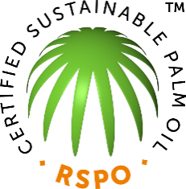
Greenpeace states its goal is to "ensure the ability of the Earth to nurture life in all its diversity" and focuses its campaigning on worldwide issues such as climate change, deforestation, overfishing, commercial whaling, genetic engineering, and anti-nuclear issues. It uses direct action, lobbying, research, and ecotage to achieve its goals. | WWF is the world's largest conservation organization with over five million supporters worldwide, working in more than 100 countries, supporting around 1,300 conservation and environmental projects. WWF aims to "stop the degradation of the planet's natural environment and to build a future in which humans live in harmony with nature. | The Roundtable on Sustainable Palm Oil (RSPO) was established in 2004 with the objective of promoting the growth and use of sustainable oil palm products through credible global standards and engagement of stakeholders.

Using the resources on ibgeographypods, add information to each of the sections below. Colour code the text to indicate which of the three civil society organisations the responses come from
Factor | Social | Environmental
How do they raise awareness?
What are their solutions to reduce the impacts?
To what extent have their solutions been successful?

