IB Geography The Circular Economy – From Linear to Circular
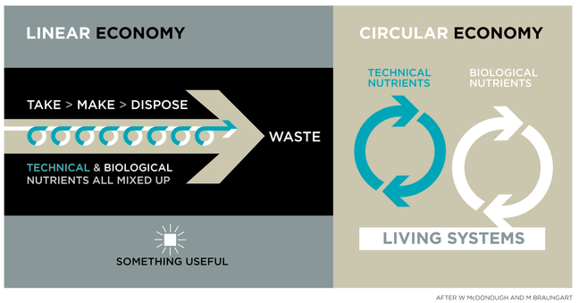
Your mobile phone ___________________________ (note links to e-waste earlier in the unit).
Take | Make | Dispose | Waste
A possible new circular economy approach
Notes on how you may adapt the system to fit in with the circular economy framework thinking about both technical and biological nutrient cycling.

My mobile – Adopting the Circular Approach – Technical Nutrients

Your mobile phone (enter make & version here)

How could these technical nutrients be ‘recycled’ and kept apart during the cycling process?
My mobile – Adopting the Circular Approach – Biological Nutrients

Your mobile phone (enter make & version here)

How could these biological nutrients be ‘recycled’ or returned to the earth?

