IB Geography – Recycling – The China Flow

5. How has the ban impacted on the flow of waste?
1. Why waste was sent to China

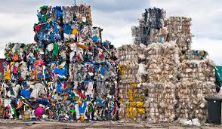
3. When did China introduce the ban?
2. What type of waste?
4. Why did it introduce the ban?

