Notes: How much oil is left on earth?
IB DP Geography – Changing Importance of Hydrocarbons

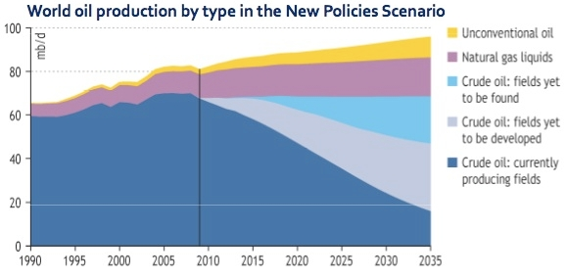

- According to this graph, what year was peak Crude Oil extraction reached?

- Describe the best-case scenario for the continued use of Crude Oil between now and 2035

Hubbert’s Peak Graph – Sketch & Explanation
Video notes on ‘The Future of Oil Demand’

