IB DP Geography – Bid Rent of Land

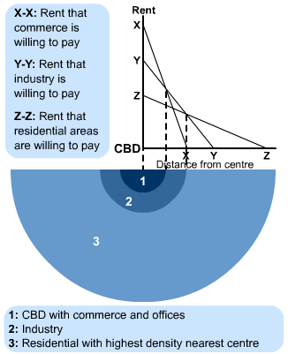

What is the relationship between the location of the CBD and price of land?

Notes on commerce (retail) rent

Notes on industrial rent.

Notes on residential rent.

What are the limitations of the model?

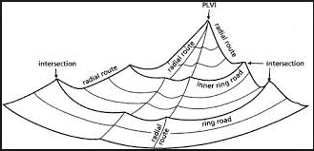

How might the more recent 3D land value model be representative of modern urban areas?

