IBDP Geography – BBC Inquiry – Are we running out of water?
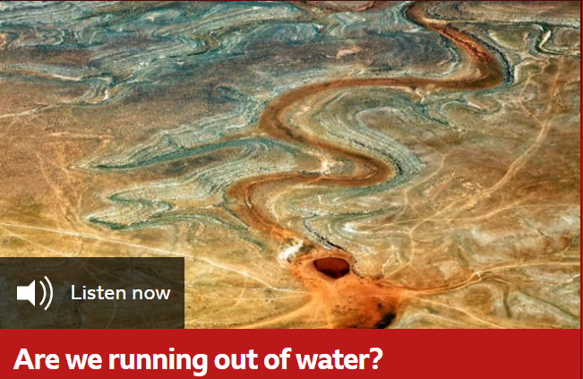
Witness 1 - James Famiglietti, Executive Director at the Global Institute for Water Security at the University of Saskatchewan. Key quote.

Witness 2 - Samrat Basak, Director of India’s Urban Water Programme for the World Resources Institute. Key quote

Witness 3 - Kate Brauman, Lead Scientist for the Global Water Initiative at the University of Minnesota. Key quote
Witness 3 - Daniel Shemie, Resilient Watersheds Strategy Director at The Nature Conservancy. Key quote

100-word summary including any links into other areas of the geography course. Are we running out of water?

