IB DP Geography – Climate Change & Agriculture
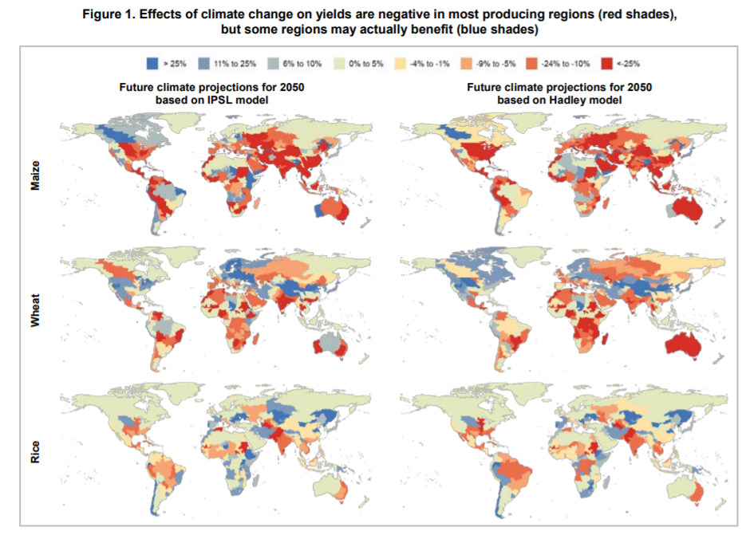
Climate change is partially brought about by the environmental impacts of agriculture. Agricultural activity will be impacted by climate change in the future in negative and sometimes positive ways. Using the embedded PDF on geographypods as well as the key maps above, outline to what extent agricultural systems and climate change are interlinked.

Think about areas experiencing permafrost melt and future cultivation (changing cultivation limits), changing crop yields (rice, wheat & maize), cultivation of land as carbon release mechanism, redistribution of global populations, positive or negative feedback loops, global hunger, geopolitics etc.

