IB DP Geography – Climate & Aerosol Dimming

Process | Place
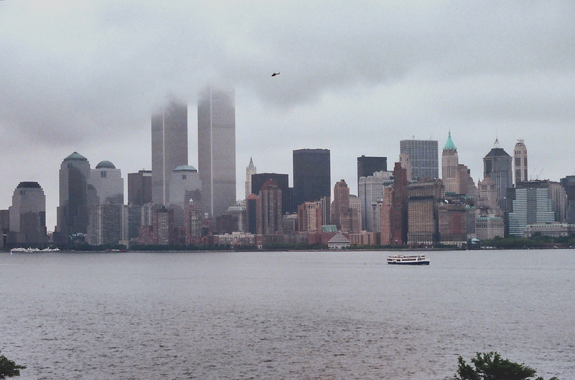

Power | Possibility

Perspectives….

